UNITED STATES
SECURITIES AND EXCHANGE COMMISSION
Washington, D.C. 20549

FORM 8-K

CURRENT REPORT
Pursuant to Section 13 or 15(d)
of the Securities Exchange Act of 1934
Date of report (Date of earliest event reported): July 28, 2026

INNIO N.V.
(Exact name of registrant as specified in its charter)

The Netherlands |  | 001-43329 |  | Not Applicable
(State or other jurisdiction  of incorporation) |  | (Commission  File Number) |  | (I.R.S. Employer  Identification No.)

Nymphenburger Strasse 5  80335 Munich  Germany |  | 1101 W. St. Paul Ave.  Waukesha, WI 53188
(Address of principal executive offices) (Zip Code)

+49.89.2500381-0 |  | +1.262.547.3311
(Registrant’s telephone number, including area code)
N/A
(Former name or former address, if changed since last report)

Check the appropriate box below if the Form 8-K filing is intended to simultaneously satisfy the filing obligation of the registrant under any of the following provisions:

☐ | Written communications pursuant to Rule 425 under the Securities Act (17 CFR 230.425)

☐ | Soliciting material pursuant to Rule 14a-12 under the Exchange Act (17 CFR 240.14a-12)

☐ | Pre-commencement communications pursuant to Rule 14d-2(b) under the Exchange Act (17 CFR 240.14d-2(b))

☐ | Pre-commencement communications pursuant to Rule 13e-4(c) under the Exchange Act (17 CFR 240.13e-4(c))
Securities registered pursuant to Section 12(b) of the Act:

Title of each class |  | Trading  Symbol(s) |  | Name of each exchange  on which registered
Common shares, nominal value €0.04 per share |  | INIO |  | The Nasdaq Stock Market LLC
Indicate by check mark whether the registrant is an emerging growth company as defined in Rule 405 of the Securities Act of 1933 (§230.405 of this chapter) or Rule 12b-2 of the Securities Exchange Act of 1934 (§240.12b-2 of this chapter).
Emerging growth company ☐
If an emerging growth company, indicate by check mark if the registrant has elected not to use the extended transition period for complying with any new or revised financial accounting standards provided pursuant to Section 13(a) of the Exchange Act. ☐

Item 2.02. | Results of Operations and Financial Condition.
On July 28, 2026, INNIO N.V. (the “Company”) issued a press release announcing its financial results for the quarter ended June 30, 2026. A copy of the press release is furnished as Exhibit 99.1 to this Current Report on Form 8-K.

Item 7.01. | Regulation FD Disclosure.
On July 28, 2026, the Company posted a corporate slide presentation with financial results for the quarter ended June 30, 2026 on its investor relations website, https://www.innio.com/en/news/. The presentation is furnished as Exhibit 99.2 to this Current Report on Form 8-K.
The information contained in Item 2.02, including Exhibit 99.1 hereto, and in Item 7.01, including Exhibit 99.2 hereto, shall not be deemed “filed” for purposes of Section 18 of the Securities Exchange Act of 1934, as amended (the “Exchange Act”), or otherwise subject to the liabilities of that section, nor shall it be deemed incorporated by reference in any filing made by the Company under the Securities Act of 1933, as amended, or the Exchange Act, regardless of any general incorporation language in such filings, unless expressly incorporated by specific reference in such filing.

Item 9.01. | Financial Statements and Exhibits.
(d) Exhibits.
The following exhibits shall be deemed to be furnished, and not filed:

Exhibit  No. |  | Description
99.1 |  | Press Release dated July 28, 2026.
99.2 |  | Earnings Presentation for the Quarter Ended June 30, 2026.
104 |  | Cover Page Interactive Data File (embedded within the Inline XBRL document).

SIGNATURES
Pursuant to the requirements of the Securities Exchange Act of 1934, the registrant has duly caused this report to be signed on its behalf by the undersigned hereunto duly authorized.

 |  |  |  | INNIO N.V.
Date: July 28, 2026 |  |  |  | By: |  | /s/ Olaf Berlien
 |  |  |  |  |  | Dr. Olaf Berlien
 |  |  |  |  |  | President and Chief Executive Officer
 |  |  |  | By: |  | /s/ Dennis Schulze
 |  |  |  |  |  | Dr. Dennis Schulze
 |  |  |  |  |  | Chief Financial Officer
Exhibit 99.1


PRESS RELEASE
INNIO Group Reports Second Quarter 2026 Financial Results
INNIO Delivers Strong Performance with Record Equipment Order Intake as Demand for Reliable Power Accelerates
Second Quarter 2026 Financial Highlights

 |  | Equipment Order Intake: $2.3 billion in Q2 2026, up 316% year-over-year, with strong momentum across our data center, power solutions and compression business lines
 |  | Equipment Order Backlog: $6.6 billion, up 279% year-over-year to a record level, providing strong revenue visibility that INNIO believes will extend at least into 2030
 |  | Total Revenue: $937.7 million in Q2 2026, up 42% year-over-year
 |  | Equipment Revenue: $569.3 million, up 61% year-over-year in Q2 2026, driven by all three business lines, with particularly strong momentum from the data center business line
 |  | Services Revenue: $368.4 million in Q2 2026, up 21% year-over-year, underpinned by long-term service agreements
 |  | Net Loss: $(16.9) million in Q2 2026, mainly due to $81.2 million of one-off costs incurred for the initial public offering and public market readiness. Net Income in Q2 2025 was $62.4 million
 |  | Adjusted EBITDA1: $172.3 million in Q2 2026, up 20% year-over-year, reflecting continued profitable growth and balanced investment in manufacturing capacity ramp-up
 |  | Fiscal Year 2026 outlook: Total Revenue growth to $3.8 - $3.9 billion and Adjusted EBITDA2 increase to $720 - $740 million
MUNICH, Germany, (July 28, 2026) — INNIO N.V. (Nasdaq: INIO), a leading global distributed energy solutions provider, today reported financial results for the second quarter ended June 30, 2026. This represents the Company’s first earnings announcement following its initial public offering which closed on June 5, 2026. INNIO delivered a quarter with profitable growth, driven by continued high demand. Equipment Order Intake reached a record level and has already exceeded the company’s full-year 2025 level, fueled by the buildout of AI infrastructure and the growing need for reliable, decentralized power across industries and geographies.
“Our results demonstrate the accelerating demand for reliable, flexible and efficient energy solutions. Our Equipment Order Backlog has reached a record of $6.6 billion, driven by all business lines. A highlight for the quarter was a landmark 1.1-gigawatt order for prime power for a data center operator, reflecting customers’ confidence in our technology, execution capabilities and ability to scale. As demand for decentralized power continues to grow, we are investing in a balanced expansion of capacity, positioning us to deliver sustainable growth and long-term value creation,” said Dr. Olaf Berlien, President and CEO of INNIO.
“Demand is accelerating across all of our business lines. We are delivering strong top-line growth in Equipment and Services as we execute on our Equipment Order Backlog. The success of our multi-year capacity expansion plan across the U.S. and Europe is already visible today as we continuously increase our output. Based on our strong first-half performance and confidence in the trajectory of the business we are initiating our outlook for the full year of 2026,” said Dr. Dennis Schulze, CFO of INNIO.

Outlook Fiscal Year 2026 |  | Fiscal Year 2026 Outlook |  | Fiscal Year 2025
Total Revenue |  | $3.8 - $3.9 billion |  | $2.6 billion
Adjusted EBITDA2 |  | $720 - $740 million |  | $549 million

1 For definitions, please refer to “Non-GAAP Financial Measures and Key Performance Indicators“ below. Please also refer to the tables under “Reconciliations of GAAP to Non-GAAP Financial Measures“ below.
2 A reconciliation of Adjusted EBITDA guidance to net income is not available on a forward-looking basis without unreasonable effort.



Company Updates

 |  | 1.1 Gigawatt (GW) Gas Engine Order from a new customer for Major Data Center Campus, one of the largest in INNIO’s history, underscores growing demand for reliable and flexible on-site prime power solutions.
 |  | Multi-year strategic framework agreement with Rehlko, securing supply of approximately 1.25 GW of gas engine capacity over three years – expanding Rehlko’s existing 700-megawatt (MW) firm reservation.
 |  | Diversified customer base further strengthened by multiple orders across the data center, power solutions, and compression business lines.
 |  | INNIO and the Net Zero Innovation Hub for Data Centers completed an industry-first demonstration of 100% hydrogen backup power at the 3 MW scale. Technical experts from Microsoft, Google, and Data4 witnessed live testing to assess performance against operational data center requirements.
Group Results

($ in millions, other than percentages and per share amounts) |  | Three Months Ended June 30, |  |  |  |  |  |  |  | Six Months Ended June 30,
 |  | 2026 |  |  |  | 2025 |  |  |  | 2026 |  |  |  | 2025
GAAP Metrics
Net Sales |  |  | 937.7 |  |  |  | 659.5 |  |  |  | 1,606.5 |  |  |  | 1,153.5
Net Income (loss) |  |  | (16.9) |  |  |  | 62.4 |  |  |  | (25.9) |  |  |  | 97.4
Net Income (loss) margin |  |  | (1.8)% |  |  |  | 9.5% |  |  |  | (1.6)% |  |  |  | 8.4%
Earnings Per Share (EPS) |  |  | (0.02) |  |  |  | 0.08 |  |  |  | (0.03) |  |  |  | 0.13
NON-GAAP Metrics
Adjusted EBITDA3 |  |  | 172.3 |  |  |  | 144.1 |  |  |  | 294.8 |  |  |  | 258.1
Adjusted EBITDA margin3 |  |  | 18.4% |  |  |  | 21.8% |  |  |  | 18.4% |  |  |  | 22.4%
Adjusted Net Income4 |  |  | 57.4 |  |  |  | 65.4 |  |  |  | 63.0 |  |  |  | 102.2
Diluted Adjusted EPS4 |  |  | 0.08 |  |  |  | 0.09 |  |  |  | 0.08 |  |  |  | 0.14
Key Performance Indicators
Equipment Order Intake3 |  |  | 2,290 |  |  |  | 550 |  |  |  | 3,908 |  |  |  | 1,203
Equipment Order Backlog3 |  |  | 6,576 |  |  |  | 1,735 |  |  |  | 6,576 |  |  |  | 1,735
INNIO delivered a strong second quarter, with broad-based momentum across all business lines. Total revenue was $937.7 million in Q2 2026, an increase of 42% year-over-year, while first-half revenue totaled $1.6 billion. Net loss for the second quarter was $(16.9) million, compared to a net income of $62.4 million in the second quarter 2025. Net-loss in Q2 2026 reflects, among other factors, one-off costs of $81.2 million for IPO and public market readiness. Net loss for the first-half 2026 was $(25.9) million, compared to a Net Income of $97.4 million in the first half 2025. Net loss margin in Q2 2026 was (1.8)% compared to Net Income margin of 9.5% in Q2 2025 and (1.6)% year-to-date compared to Net Income margin of 8.4% in the first half of 2025. Adjusted Net Income4 was $57.4 million in the second quarter of 2026, compared to $65.4 million in the prior-year period.
Adjusted EBITDA was $172.3 million in the quarter, increasing 20% year-over-year, and reached $294.8 million for the first six months of 2026. Adjusted EBITDA in the second quarter included, among other factors, significant investments in technology leadership and balanced capacity expansion in North America and Austria.

3 For definitions, please refer to “Non-GAAP Financial Measures and Key Performance Indicators“ below. Please also refer to the tables under “Reconciliations of GAAP to Non-GAAP Financial Measures“ below.
4 Adjusted Net Income includes the effect of unrealized foreign currency revaluation gains/losses from external and internal USD loans in EUR functional currency entities. For the three months ended June 30, 2026 and 2025, these amounted to a $(11.9) million loss and $13.8 million gain, respectively, or an unfavorable variance of $(25.7) million. For the six months ended June 30, 2026, and 2025, these amounted to a $(35.4) million loss and $22.0 million gain, respectively, or an unfavorable variance of $(57.4) million.

At the end of the second quarter, Equipment Order Backlog totaled $6.6 billion, driven by exceptional data center demand and strong growth in power generation and gas compression solutions. At the end of the first quarter 2026 Equipment Order Backlog was $4.9 billion, and $1.7 billion at the end of the second quarter of 2025. The increase in Equipment Order Backlog was driven, amongst other factors, by the landmark 1.1 GW prime power order from a developer and operator of data centers, follow-on orders from a hyperscaler and the multi-year strategic framework agreement with Rehlko.
Reporting Segments
Equipment

 |  | Three Months Ended June 30, |  |  |  |  |  |  |  | Six Months Ended June 30,
($ in millions) |  | 2026 |  |  |  | 2025 |  |  |  | 2026 |  |  |  | 2025
Equipment
Revenue |  |  | 569.3 |  |  |  | 354.1 |  |  |  | 891.8 |  |  |  | 564.3
Adjusted Segment EBITDA |  |  | 78.6 |  |  |  | 66.1 |  |  |  | 101.5 |  |  |  | 94.3
Adjusted Segment EBITDA margin |  |  | 13.8% |  |  |  | 18.7% |  |  |  | 11.4% |  |  |  | 16.7%
INNIO’s Equipment segment delivered another quarter of exceptional growth. Q2 2026 Equipment Order Intake reached $2.3 billion, representing 316% growth year-over-year, driven by the landmark 1.1 GW prime power order, follow-on hyperscaler orders and continued strength across power solutions and compression markets.
First-half Equipment Order Intake reached $3.9 billion.
Disciplined execution of Equipment Order Backlog translated into Equipment Revenue of $569.3 million in Q2 2026 and $891.8 million in the first half. Adjusted Segment EBITDA was $78.6 million in Q2 2026 and $101.5 million year-to-date. Revenue and Adjusted EBITDA increased as a result of a strong conversion of the expanding Equipment Order Backlog, based on improvements in production and capacity expansion.
Services

 |  | Three Months Ended June 30, |  |  |  |  |  |  |  | Six Months Ended June 30,
($ in millions) |  | 2026 |  |  |  | 2025 |  |  |  | 2026 |  |  |  | 2025
Services
Revenue |  |  | 368.4 |  |  |  | 305.4 |  |  |  | 714.7 |  |  |  | 589.2
Adjusted Segment EBITDA |  |  | 109.8 |  |  |  | 85.9 |  |  |  | 219.8 |  |  |  | 176.2
Adjusted Segment EBITDA margin |  |  | 29.8% |  |  |  | 28.1% |  |  |  | 30.8% |  |  |  | 29.9%
INNIO’s Services segment continued to generate strong recurring revenue growth. Services revenue reached $368.4 million in Q2 2026, an increase of 21% year-over-year, while first-half revenue totaled $714.7 million.
Adjusted Services Segment EBITDA reached $109.8 million in Q2 and $219.8 million in the first half, benefiting from strong customer demand for spare parts, remanufacturing and long-term service agreements.

The financial information presented in this release is unaudited. Additional information regarding INNIO’s second quarter 2026 results will be available in the Company’s Quarterly Report on Form 10-Q for the quarter ended June 30, 2026, which the Company expects to file with the U.S. Securities and Exchange Commission.
Conference Call Information
INNIO Group will host a conference call and webcast at 8:00 a.m. EDT on July 28, 2026, to discuss its second quarter 2026 results. The webcast will be available at http://investors.innio.com. A replay will be available for 365 days following the call.
About INNIO N.V.
INNIO N.V. (Nasdaq: INIO) is a global distributed energy solutions provider that delivers reliable, flexible, transient, decentralized, modular, and efficient power. With a track record of innovation, INNIO designs, manufactures, and services high-performance power systems under its Jenbacher and Waukesha brands. The company delivers power for applications including data centers, microgrids, grid stabilization, industrial energy, and gas compression.
INNIO has global coverage across approximately 100 countries as of December 31, 2025, supported by a resilient, high-margin services business that delivers long-term, recurring revenues across the full equipment lifecycle. As electricity demand accelerates—driven by AI, electrification, and grid constraints—INNIO enables scalable, behind-the-meter power generation with high efficiency, fast-start capability, strong transient performance, and fuel flexibility, including hydrogen-ready solutions. Headquartered in Munich, Germany, INNIO employs over 5,000 people worldwide and is committed to moving energy forward.
Contacts
Media Contact
Stefan Schmidt, INNIO
+43 664 80833 2626
stefan.schmidt@innio.com
Alexander Becker, INNIO
+43 664 80833 1998
alexander.becker@innio.com
Investor Relations
Timothy Furcillo, INNIO
+1 262 2690525
timothy.furcillo@innio.com
Forward-Looking Statements
This press release includes forward-looking statements within the meaning of the safe harbor provisions of the Private Securities Litigation Reform Act of 1995. All statements other than statements of historical fact contained in this press release, including statements regarding our future results of operations and financial position, industry dynamics, business strategy and plans and our objectives for future operations are forward-looking statements. In some cases, you can identify forward-looking statements by terms such as “may,” “will,” “should,” “aim,” “expect,” “plan,” “anticipate,” “could,” “intend,” “target,” “project,” “contemplate,” “believe,” “estimate,” “predict,” “potential” or “continue” or the negative of these words or other similar terms or expressions that are intended to identify forward-looking statements.

These forward-looking statements involve known and unknown risks, uncertainties, changes in circumstances that are difficult to predict and other important factors that may cause our actual results, performance or achievements to be materially different from any future results, performance or achievements expressed or implied by the forward-looking statement including, but not limited to: changes in macroeconomic and market conditions and market volatility, including risk of recession, inflation, supply chain constraints or disruptions, interest rates, the value of securities and other financial assets, oil, natural gas and other commodity prices and exchange rates, and the impact of such changes and volatility on our business operations, financial results and financial position; global economic trends, competition and geopolitical risks, including impacts from the ongoing geopolitical conflicts (such as the Iran conflict, Russia-Ukraine conflict, ongoing tensions between the United States and China and China and Taiwan), demand or supply shocks from events such as a major terrorist attack, natural disasters or actual or threatened public health pandemics or other emergencies, or an escalation of sanctions, tariffs or other trade tensions, and related impacts on our supply chains and strategies; our ability to successfully execute our business and growth strategy; our future financial performance, including our expectations regarding the performance of our Services segment, our revenue, operating expenses and ability to remain profitable; economic and industry trends, projected growth, or trend analysis, particularly as it relates to AI; our ability to develop and introduce new technologies to meet market demand and evolving customer needs, which depends on many factors, including the ability to obtain any required permits, licenses, and registrations; our ability to attract and retain highly qualified personnel; our expectations concerning relationships with our channel partners and distribution network; our ability to manage and predict our backlog; actual or perceived quality issues or safety failures related to our complex and specialized products, solutions and services; significant disruptions in our supply chain, including the high cost or unavailability of raw materials, components, and products essential to our business, and significant disruptions to our manufacturing and production facilities and distribution networks; our ability to obtain, maintain, protect, and effectively enforce our intellectual property rights; our capital allocation plans, including the timing and amount of dividends; shifts in market and other dynamics related to electrification, decarbonization or sustainability; the amount and timing of our cash flows and earnings, which may be impacted by macroeconomic, customer, supplier, competitive, contractual and other dynamics and conditions; actions by our joint venture arrangements and similar collaborations with third parties for certain projects that result in additional costs and obligations; any reductions or modifications to, or the elimination of, governmental incentives or policies that support renewable energy and energy transition innovation and technology; our ability to stay in compliance with laws and regulations that currently apply or may become applicable to our business both in the United States and internationally and changes in law, regulation or policy that may affect our businesses; our ability to maintain the security and availability of our platform and protect against data breaches and other security incidents; our ability and challenges to our operations as a public company, including the increased expenses associated with being a public company, or achieve some or all of the benefits we expect to achieve; the risk of significant volatility in our share price; our ability to retain tax residency in Germany; our ability to remediate the material weaknesses we identified in our internal control over financial reporting or prevent material weaknesses in the future; and other statements regarding our future operations, financial condition, and prospects and business strategies. In light of these risks, uncertainties and assumptions, the forward-looking events and circumstances discussed in this press release may not occur and actual results could differ materially and adversely from those anticipated or implied in the forward-looking statements. We caution you therefore against relying on these forward-looking statements, and we qualify all of our forward-looking statements by these cautionary statements. For additional information on other potential risks and uncertainties that could cause actual results to differ from expected results, please refer to our filings with the Securities and Exchange Commission.
The forward-looking statements included in this press release are made only as of the date hereof. The Company undertakes no obligation to update any forward-looking statements for any reason after the date of this press release to conform these statements to actual results or to changes in our expectations, except as may be required by law.

Consolidated Statements of Operations
(Unaudited)

 |  | Three Months Ended June 30, |  |  |  |  |  |  |  | Six Months Ended June 30,
(in millions of $, except share and per share  amounts) |  | 2026 |  |  |  | 2025 |  |  |  | 2026 |  |  |  | 2025
Sales of equipment and products |  | $ | 569.3 |  |  | $ | 354.1 |  |  | $ | 891.8 |  |  | $ | 564.3
Sales of services |  |  | 368.4 |  |  |  | 305.4 |  |  |  | 714.7 |  |  |  | 589.2
Net sales |  |  | 937.7 |  |  |  | 659.5 |  |  |  | 1,606.5 |  |  |  | 1,153.5
Cost of equipment and products sold |  |  | 421.6 |  |  |  | 251.0 |  |  |  | 662.5 |  |  |  | 397.5
Cost of services sold |  |  | 208.2 |  |  |  | 180.1 |  |  |  | 402.3 |  |  |  | 338.2
Gross profit |  |  | 307.9 |  |  |  | 228.4 |  |  |  | 541.7 |  |  |  | 417.8
Selling, general, and administrative expenses |  |  | 232.2 |  |  |  | 101.4 |  |  |  | 375.2 |  |  |  | 198.4
Research and development expenses |  |  | 31.9 |  |  |  | 27.2 |  |  |  | 60.8 |  |  |  | 46.4
Other operating (income) expense - net |  |  | (1.3) |  |  |  | (1.3) |  |  |  | (2.5) |  |  |  | (3.1)
Operating income |  |  | 45.1 |  |  |  | 101.1 |  |  |  | 108.2 |  |  |  | 176.1
Interest expense and related financing costs - net |  |  | 52.9 |  |  |  | 21.5 |  |  |  | 123.7 |  |  |  | 50.1
Other (income) expense - net |  |  | (3.7) |  |  |  | (0.9) |  |  |  | (6.9) |  |  |  | (1.5)
Income (loss) before income taxes |  |  | (4.1) |  |  |  | 80.5 |  |  |  | (8.6) |  |  |  | 127.5
Income tax expense |  |  | 12.8 |  |  |  | 18.1 |  |  |  | 17.3 |  |  |  | 30.1
Net income (loss) |  |  | (16.9) |  |  |  | 62.4 |  |  |  | (25.9) |  |  |  | 97.4
Net income (loss) attributable to non-  controlling interests |  |  | (1.6) |  |  |  | (0.1) |  |  |  | (3.4) |  |  |  | (0.1)
Net income (loss) attributable to INNIO  N.V. shareholders |  | $ | (15.3) |  |  | $ | 62.5 |  |  | $ | (22.5) |  |  | $ | 97.5
Earnings (loss) per share attributable to
INNIO N.V.:
Basic |  |  | (0.02) |  |  |  | 0.08 |  |  |  | (0.03) |  |  |  | 0.13
Diluted |  |  | (0.02) |  |  |  | 0.08 |  |  |  | (0.03) |  |  |  | 0.13
Weighted-average number of shares
outstanding:
Basic |  |  | 750,000,000 |  |  |  | 750,000,000 |  |  |  | 750,000,000 |  |  |  | 750,000,000
Diluted |  |  | 750,000,000 |  |  |  | 750,000,000 |  |  |  | 750,000,000 |  |  |  | 750,000,000

Consolidated Statements of Comprehensive Income / (Loss)
(Unaudited)

 |  | Three Months Ended June 30, |  |  |  |  |  |  |  | Six Months Ended June 30,
(in millions of $) |  | 2026 |  |  |  | 2025 |  |  |  | 2026 |  |  |  | 2025
Net income (loss) |  | $ | (16.9) |  |  | $ | 62.4 |  |  | $ | (25.9) |  |  | $ | 97.4
Other comprehensive income (loss), net of
taxes:
Defined benefit plans |  |  | 0.4 |  |  |  | 0.7 |  |  |  | (1.0) |  |  |  | 0.6
Currency translation adjustments |  |  | 7.6 |  |  |  | 26.3 |  |  |  | 15.7 |  |  |  | 37.6
Cash flow hedges |  |  | (9.2) |  |  |  | (5.6) |  |  |  | (9.5) |  |  |  | (7.5)
Total other comprehensive income (loss), net of taxes |  |  | (1.2) |  |  |  | 21.4 |  |  |  | 5.2 |  |  |  | 30.7
Comprehensive income (loss) |  |  | (18.1) |  |  |  | 83.8 |  |  |  | (20.7) |  |  |  | 128.1
Less: comprehensive income (loss)  attributable to the noncontrolling interests |  |  | (1.8) |  |  |  | (0.1) |  |  |  | (3.7) |  |  |  | (0.1)
Comprehensive income (loss) attributable  to INNIO N.V. shareholders |  | $ | (16.3) |  |  | $ | 83.9 |  |  | $ | (17.0) |  |  | $ | 128.2

Consolidated Statements of Financial Position
(Unaudited)

(in millions of $, except share data) |  | June 30, 2026 |  |  |  | December 31, 2025
Assets
Current assets:
Cash and cash equivalents |  | $ | 1,039.9 |  |  | $ | 689.5
Accounts receivable - net |  |  | 234.2 |  |  |  | 204.4
Inventories |  |  | 958.1 |  |  |  | 601.2
Prepaid expenses |  |  | 175.2 |  |  |  | 117.9
Other current assets |  |  | 207.9 |  |  |  | 180.8
Total current assets |  |  | 2,615.3 |  |  |  | 1,793.8
Property, plant, and equipment - net |  |  | 599.1 |  |  |  | 540.4
Goodwill |  |  | 1,648.8 |  |  |  | 1,686.6
Intangible assets - net |  |  | 719.7 |  |  |  | 777.3
Other non-current assets |  |  | 141.1 |  |  |  | 104.4
Total assets |  | $ | 5,724.0 |  |  | $ | 4,902.5
Liabilities
Current liabilities
Accounts payable |  | $ | 466.7 |  |  | $ | 273.3
Contract liabilities |  |  | 970.1 |  |  |  | 546.2
Accrued liabilities |  |  | 235.4 |  |  |  | 186.1
Obligations under supplier finance programs |  |  | 181.2 |  |  |  | 157.0
Obligations related to factoring arrangements |  |  | 43.0 |  |  |  | 59.5
Other current liabilities |  |  | 194.5 |  |  |  | 153.7
Total current liabilities |  |  | 2,090.9 |  |  |  | 1,375.8
Long-term debt - net |  |  | 2,607.1 |  |  |  | 2,647.4
Contract liabilities |  |  | 426.8 |  |  |  | 269.9
Deferred taxes |  |  | 204.3 |  |  |  | 214.6
Other non-current liabilities |  |  | 175.8 |  |  |  | 166.7
Total liabilities |  |  | 5,504.9 |  |  |  | 4,674.4
Commitments and guarantees
Shareholders’ equity
Common stock, 0.04 nominal value; 750,000,000 shares issued and outstanding |  |  | 34.9 |  |  |  | 34.9
Additional paid-in capital |  |  | 111.6 |  |  |  | 103.2
Retained earnings |  |  | 77.8 |  |  |  | 100.3
Accumulated other comprehensive loss |  |  | (15.1) |  |  |  | (20.6)
Total INNIO N.V. shareholders’ equity |  |  | 209.2 |  |  |  | 217.8
Non-controlling interests |  |  | 9.9 |  |  |  | 10.3
Total shareholders’ equity |  |  | 219.1 |  |  |  | 228.1
Total liabilities and shareholders’ equity |  | $ | 5,724.0 |  |  | $ | 4,902.5

Consolidated Statements of Cash Flows
(Unaudited)

 |  | Six Months Ended June 30,
(in millions of $) |  | 2026 |  |  |  | 2025
Net income (loss) |  | $ | (25.9) |  |  | $ | 97.4
Adjustments to reconcile net income to cash from operating activities
Depreciation of property, plant, and equipment |  |  | 33.6 |  |  |  | 26.7
Amortization of intangible assets |  |  | 44.7 |  |  |  | 45.4
Accrued long-term incentive plan compensation |  |  | 61.5 |  |  |  | —
Foreign currency losses (gains) |  |  | 33.7 |  |  |  | (11.7)
Amortization of operating lease right-of-use assets |  |  | 11.4 |  |  |  | 8.1
Other non-cash expense (income) |  |  | 32.0 |  |  |  | 11.8
Changes in assets and liabilities
Accounts receivable |  |  | (33.7) |  |  |  | 20.2
Inventories |  |  | (379.7) |  |  |  | (144.6)
Prepaid expenses |  |  | (58.8) |  |  |  | (4.1)
Accounts payable |  |  | 205.3 |  |  |  | 19.3
Contract liabilities |  |  | 594.5 |  |  |  | 100.5
Accrued liabilities |  |  | (7.3) |  |  |  | (38.1)
All other assets and liabilities |  |  | (67.7) |  |  |  | (40.3)
Net cash provided by operating activities |  |  | 443.6 |  |  |  | 90.6
Additions to property, plant, and equipment |  |  | (94.1) |  |  |  | (39.4)
Additions to intangible assets |  |  | (7.5) |  |  |  | (8.8)
All other investing activities |  |  | 0.3 |  |  |  | 2.3
Net cash used for investing activities |  |  | (101.3) |  |  |  | (45.9)
Repayment of loans and borrowings |  |  | (3.8) |  |  |  | (3.0)
Proceeds / (payments) from supplier finance programs, net |  |  | 29.2 |  |  |  | 52.4
Payments for obligations from finance lease and sale-and-leaseback transactions |  |  | (1.7) |  |  |  | (2.2)
Proceeds from contribution from non controlling interest |  |  | 3.3 |  |  |  | —
Transaction costs related to new loans and refinancing of existing loans |  |  | (6.6) |  |  |  | —
All other financing activities |  |  | (2.9) |  |  |  | (1.9)
Net cash provided by financing activities |  |  | 17.5 |  |  |  | 45.3
Effect of currency exchange rate changes on cash and cash equivalents |  |  | (9.4) |  |  |  | 16.9
Increase in cash and cash equivalents |  |  | 350.4 |  |  |  | 106.8
Cash and cash equivalents at the beginning of the period |  |  | 689.5 |  |  |  | 378.5
Cash and cash equivalents at the end of the period |  | $ | 1,039.9 |  |  | $ | 485.3
Supplemental disclosure of cash flows information
Cash paid during the period for interest |  |  | (91.9) |  |  |  | (73.2)

Non-GAAP Financial Measures and Key Performance Indicators
Non-GAAP Financial Measures
We report our financial results in accordance with U.S. GAAP. We believe that certain non-GAAP financial measures provide our investors with additional useful information in evaluating our performance. We believe that excluding certain items that may vary substantially in frequency and magnitude period-to-period from net income creates useful, supplemental measures that may assist our investors in evaluating our ability to generate earnings and to more readily compare these metrics between past and future periods. These non-GAAP financial measures may be different than similarly titled measures used by other companies.
We define Adjusted EBITDA as net income as adjusted for (i) income tax expense, (ii) interest and other financial charges – net, (iii) other non–operating (income)/expense – net, (iv) depreciation and amortization, (v) other non–cash items, (vi) public market readiness costs, (vii) transformation costs, (viii) transaction costs, (ix) acquisition and divestment related gains and losses and (x) share-based compensation. We define Adjusted EBITDA Margin as Adjusted EBITDA divided by revenue.
We define Cash Conversion as Adjusted EBITDA less capital expenditures, divided by Adjusted EBITDA. Capital expenditures are the sum of the additions to property, plant and equipment and additions to intangible assets over a given period. Cash Conversion is a supplemental non-GAAP financial measure used by our management to evaluate the proportion of Adjusted EBITDA retained after capital expenditures in a given period and to assess capital intensity relative to operating performance and is reviewed by management as part of regular operating and financial performance reviews. Accordingly, we believe this measure provides useful information to investors in understanding and evaluating our operating results in the same manner as our management.
We define adjusted net income (“Adjusted Net Income”) as net income (loss) as adjusted for (i) management adjustments comprising (a) IPO and public market readiness costs, (b) transformation costs, (c) transaction costs, (d) acquisition and divestment related gains and losses and (e) share-based compensation expense and (ii) adjusted tax effects from management adjustments. We define adjusted earnings per share (“Diluted Adjusted EPS”) as Adjusted Net Income divided by the weighted -average number of common shares issued and outstanding and the dilutive effect computed under the treasury stock method of potential common shares issued (RSUs awarded). Diluted Adjusted EPS, derived from Adjusted Net Income is a non-GAAP financial measure used by our management to provide additional perspective and insights when analyzing the core operating performance of the Company from period to period and trends in the Company’s historical operating results. Accordingly, we believe these measures provide useful information to investors in understanding and evaluating our operating results in the same manner as our management.
Adjusted EBITDA and Adjusted EBITDA Margin should not be considered in isolation from, or as a substitute for, financial information prepared in accordance with GAAP. There are several limitations related to the use of Adjusted EBITDA and Adjusted EBITDA Margin as compared to the closest comparable GAAP measure. Some of these limitations are that this measure excludes:

 |  | depreciation and amortization, a non-cash expense, where the assets being depreciated and amortized may have to be replaced in the future, and this measure does not reflect cash capital expenditure requirements for such replacements or for new capital expenditure requirements;

 |  | interest and other financial charges - net, or the cash requirements necessary to service interest or principal payments on our indebtedness, which reduces cash available to us;

 |  | provision for income taxes, which may represent a reduction in cash available to us; and

 |  | other income for certain non-cash items that are not reflective of our ongoing operational results

Accordingly, prospective investors should not place undue reliance on Adjusted EBITDA and Adjusted EBITDA Margin.
Diluted Adjusted EPS should not be considered in isolation from, or as a substitute for, financial information prepared in accordance with GAAP such as GAAP diluted earnings per share (“Diluted EPS”). We have provided Diluted Adjusted EPS, as supplemental information and in addition to Diluted EPS which is calculated and presented in accordance with GAAP. Diluted Adjusted EPS is presented because management has evaluated the Company’s financial results both including and excluding the adjusted items and believes that Diluted Adjusted EPS provides additional perspective and insights when analyzing the core operating performance of the Company from period to period and trends in the Company’s historical operating results.
Key Performance Indicators
Equipment Order Backlog is defined as Equipment Order Intake that has not yet been fulfilled towards the customer. Equipment Order Backlog is measured as of the end of a given period.
Equipment Order Intake is defined as the booking of a new sales order for the Equipment segment within a given period when specific criteria are met, including a signed contract, defined scope, fixed price, delivery schedule, and fully defined terms and conditions. The order must have a low probability of cancellation, all necessary approvals and risk reviews completed, and any required down payment (if any) received. Equipment Order Intake is measured over a given period.

Reconciliations of GAAP to Non-GAAP Financial Measures
The following table reconciles Adjusted EBITDA and Adjusted EBITDA Margin from the most directly comparable GAAP metric, net income, for the periods presented:

 |  | Three Months Ended June 30, |  |  |  |  |  |  |  | Six Months Ended June 30,
($ in millions, other than percentages) |  | 2026 |  |  |  | 2025 |  |  |  | 2026 |  |  |  | 2025
Net income (loss) |  |  | (16.9 | ) |  |  | 62.4 |  |  |  | (25.9 | ) |  |  | 97.4
Income tax expense |  |  | 12.8 |  |  |  | 18.1 |  |  |  | 17.3 |  |  |  | 30.1
Interest expense and related financing costs - net |  |  | 52.9 |  |  |  | 21.5 |  |  |  | 123.7 |  |  |  | 50.1
Other (income) expense - net |  |  | (3.7 | ) |  |  | (0.9 | ) |  |  | (6.9 | ) |  |  | (1.5 | )
Depreciation and amortization |  |  | 40.1 |  |  |  | 37.0 |  |  |  | 78.3 |  |  |  | 72.1
Other non-cash items (a) |  |  | 2.0 |  |  |  | 2.1 |  |  |  | 5.5 |  |  |  | 3.7
IPO and Public market readiness costs (b) |  |  | 81.2 |  |  |  | 0.1 |  |  |  | 91.1 |  |  |  | 0.1
Transformation costs (c) |  |  | 1.8 |  |  |  | 3.1 |  |  |  | 5.3 |  |  |  | 5.7
Transaction costs (d) |  |  | 0.5 |  |  |  | — |  |  |  | 4.6 |  |  |  | —
Acquisition and divestment related gains (losses) - net (e) |  |  | 0.5 |  |  |  | 0.7 |  |  |  | 0.7 |  |  |  | 0.4
Share-based compensation (f) |  |  | 1.1 |  |  |  | — |  |  |  | 1.1 |  |  |  | —
Adjusted EBITDA |  |  | 172.3 |  |  |  | 144.1 |  |  |  | 294.8 |  |  |  | 258.1
Adjusted EBITDA Margin |  |  | 18.4 | % |  |  | 21.8 | % |  |  | 18.4 | % |  |  | 22.4 | %
(a) Other non–cash items include amortization expenses of capitalized costs to obtain contracts.
(b) IPO and Public market readiness costs include costs that the Company incurs to implement financial statements in US GAAP, including: implementing SOX-compliant internal controls, improving processes and organization required for public US markets, bonuses linked to successful public offering including long-term incentive plans, and legal and advisory fees related to INNIO’s IPO. During the six months ended June 30, 2026, the Company incurred the following costs:

 |  |  | Long-term incentive program 2023 $61.5 million

 |  |  | Costs related to financial statements in US GAAP $20.8 million

 |  |  | Advisory fees $4.1 million

 |  |  | Others $3.7 million

 |  |  | Legal fees $1.0 million

(c) Transformation costs include costs in a given year incurred in relation to significant operational change initiatives and the ramp up of supply chain capacity. This includes the ramp up of our business transformation efforts to support our capacity expansion initiatives to strengthen internal manufacturing and supply chain foundations, supported by dedicated third–party expertise to accelerate the capacity uplift. Costs also include those associated with streamlining management structures, processes and operational performance.
(d) Transaction costs include legal and professional fees related to our legal reorganization, as described in “—Organizational History,” and adapting INNIO’s financing structure.
(e) Acquisition and divestment related gains and losses incurred in connection with planned and completed acquisitions, including legal and professional fees. Contingent consideration arrangements (earn–outs) relate to specific acquisitions.
(f) Share-based compensation represents RSUs awarded under the 2026 Incentive Award Plan.
The following table reconciles Diluted Adjusted EPS from the most directly comparable GAAP metric, Diluted EPS, for the periods presented. Diluted Adjusted EPS is based on the Company’s 750,000,000 common shares issued and outstanding and the dilutive impact, computed under the treasury stock method, of 1,702,100 RSUs awarded for the three and six months ended June 30, 2026.

 |  | Three Months Ended June 30, |  |  |  |  |  |  |  | Six Months Ended June 30,
($ in millions, other than share and per share amounts) |  | 2026 |  |  |  | 2025 |  |  |  | 2026 |  |  |  | 2025
Total Adjusted Segment EBITDA |  |  | 188.4 |  |  |  | 152.0 |  |  |  | 321.3 |  |  |  | 270.5
Unallocated corporate costs (HQ &  other not included in Adjusted Segment EBITDA) |  |  | (16.1) |  |  |  | (7.9) |  |  |  | (26.5) |  |  |  | (12.4)
Adjusted EBITDA |  |  | 172.3 |  |  |  | 144.1 |  |  |  | 294.8 |  |  |  | 258.1
Acquisition and Divestment related gains (losses) - net |  |  | (0.5) |  |  |  | (0.7) |  |  |  | (0.7) |  |  |  | (0.4)
Transaction costs |  |  | (0.5) |  |  |  | — |  |  |  | (4.6) |  |  |  | —
Transformation costs |  |  | (1.8) |  |  |  | (3.1) |  |  |  | (5.3) |  |  |  | (5.7)
IPO and Public market readiness costs |  |  | (81.2) |  |  |  | (0.1) |  |  |  | (91.1) |  |  |  | (0.1)
Share-based compensation |  |  | (1.1) |  |  |  | — |  |  |  | (1.1) |  |  |  | —
Management adjustments |  |  | (85.1) |  |  |  | (3.9) |  |  |  | (102.8) |  |  |  | (6.2)
Other non-cash items |  |  | (2.0) |  |  |  | (2.1) |  |  |  | (5.5) |  |  |  | (3.7)
Depreciation and amortization |  |  | (40.1) |  |  |  | (37.0) |  |  |  | (78.3) |  |  |  | (72.1)
Other income (expense) - net |  |  | 3.7 |  |  |  | 0.9 |  |  |  | 6.9 |  |  |  | 1.5
Interest expense and related financing costs - net |  |  | (52.9) |  |  |  | (21.5) |  |  |  | (123.7) |  |  |  | (50.1)
Income tax expense |  |  | (12.8) |  |  |  | (18.1) |  |  |  | (17.3) |  |  |  | (30.1)
Net income (loss) |  |  | (16.9) |  |  |  | 62.4 |  |  |  | (25.9) |  |  |  | 97.4
Diluted EPS |  |  | (0.02) |  |  |  | 0.08 |  |  |  | (0.03) |  |  |  | 0.13
Management adjustments |  |  | 85.1 |  |  |  | 3.9 |  |  |  | 102.8 |  |  |  | 6.2
Adjusted tax effects |  |  | (10.8) |  |  |  | (0.9) |  |  |  | (13.9) |  |  |  | (1.4)
Adjusted Net Income* |  |  | 57.4 |  |  |  | 65.4 |  |  |  | 63.0 |  |  |  | 102.2
Diluted Adjusted EPS |  |  | 0.08 |  |  |  | 0.09 |  |  |  | 0.08 |  |  |  | 0.14
Weighted-average number of shares outstanding on a diluted basis: |  |  | 750,050,711 |  |  |  | 750,000,000 |  |  |  | 750,025,496 |  |  |  | 750,000,000
*Adjusted Net Income includes the effect of unrealized foreign currency revaluation gains/losses from external and internal USD loans in EUR functional currency entities. For the three months ended June 30, 2026 and 2025, these amounted to a $(11.9) million loss and $13.8 million gain, respectively, or an unfavourable variance of $(25.7) million. For the six months ended June 30, 2026, and 2025, these amounted to a $(35.4) million loss and $22.0 million gain, respectively, or an unfavourable variance of $(57.4) million.

Selected financial information for each segment is as follows:

 |  | Three Months Ended June 30, 2026
(in millions of $) |  | Equipment |  |  |  | Services |  |  |  | Total from  Reportable Segments
Total revenue |  |  | 569.3 |  |  |  | 368.4 |  |  |  | 937.7
Less: Significant segment expenses regularly provided to the CODM (a)
Cost of goods and services sold |  |  | (421.6) |  |  |  | (208.2) |  |  |  | (629.8)
Research and development |  |  | (20.6) |  |  |  | (11.3) |  |  |  | (31.9)
Selling, general and administrative expenses |  |  | (65.0) |  |  |  | (53.6) |  |  |  | (118.6)
Depreciation and amortization |  |  | 14.4 |  |  |  | 12.7 |  |  |  | 27.1
Other non-cash items (b) |  |  | 1.2 |  |  |  | 0.8 |  |  |  | 2.0
Management adjustments (c) |  |  | 0.4 |  |  |  | 0.9 |  |  |  | 1.3
Other segment items (d) |  |  | 0.5 |  |  |  | 0.1 |  |  |  | 0.6
Adjusted Segment EBITDA (e) |  |  | 78.6 |  |  |  | 109.8 |  |  |  | 188.4

 |  | Three Months Ended June 30, 2025
(in millions of $) |  | Equipment |  |  |  | Services |  |  |  | Total from  Reportable Segments
Total revenue |  |  | 354.1 |  |  |  | 305.4 |  |  |  | 659.5
Less: Significant segment expenses regularly provided to the CODM (a)
Cost of goods and services sold |  |  | (251.0) |  |  |  | (180.1) |  |  |  | (431.1)
Research and development |  |  | (13.9) |  |  |  | (13.3) |  |  |  | (27.2)
Selling, general and administrative expenses |  |  | (35.9) |  |  |  | (40.6) |  |  |  | (76.5)
Depreciation and amortization |  |  | 11.3 |  |  |  | 13.3 |  |  |  | 24.6
Other non-cash items (b) |  |  | 1.2 |  |  |  | 0.9 |  |  |  | 2.1
Management adjustments (c) |  |  | 0.1 |  |  |  | 0.5 |  |  |  | 0.6
Other segment items (d) |  |  | 0.2 |  |  |  | (0.2) |  |  |  | —
Adjusted Segment EBITDA (e) |  |  | 66.1 |  |  |  | 85.9 |  |  |  | 152.0

 |  | Six Months Ended June 30, 2026
(in millions of $) |  | Equipment |  |  |  | Services |  |  |  | Total from  Reportable Segments
Total revenue |  |  | 891.8 |  |  |  | 714.7 |  |  |  | 1,606.5
Less: Significant segment expenses regularly provided to the CODM (a)
Cost of goods and services sold |  |  | (662.5 | ) |  |  | (402.3 | ) |  |  | (1,064.8 | )
Research and development |  |  | (39.3 | ) |  |  | (21.5 | ) |  |  | (60.8 | )
Selling, general and administrative expenses |  |  | (120.5 | ) |  |  | (100.3 | ) |  |  | (220.8 | )
Depreciation and amortization |  |  | 27.1 |  |  |  | 25.2 |  |  |  | 52.3
Other non-cash items (b) |  |  | 3.3 |  |  |  | 2.2 |  |  |  | 5.5
Management adjustments (c) |  |  | 0.6 |  |  |  | 1.5 |  |  |  | 2.1
Other segment items (d) |  |  | 1.0 |  |  |  | 0.3 |  |  |  | 1.3
Adjusted Segment EBITDA (e) |  |  | 101.5 |  |  |  | 219.8 |  |  |  | 321.3

 |  | Six Months Ended June 30, 2025
(in millions of $) |  | Equipment |  |  |  | Services |  |  |  | Total from  Reportable Segments
Total revenue |  |  | 564.3 |  |  |  | 589.2 |  |  |  | 1,153.5
Less: Significant segment expenses regularly provided to the CODM (a)
Cost of goods and services sold |  |  | (397.5 | ) |  |  | (338.2 | ) |  |  | (735.7 | )
Research and development |  |  | (23.8 | ) |  |  | (22.6 | ) |  |  | (46.4 | )
Selling, general and administrative expenses |  |  | (73.3 | ) |  |  | (80.9 | ) |  |  | (154.2 | )
Depreciation and amortization |  |  | 21.9 |  |  |  | 26.1 |  |  |  | 48.0
Other non-cash items (b) |  |  | 2.1 |  |  |  | 1.6 |  |  |  | 3.7
Management adjustments (c) |  |  | 0.1 |  |  |  | 0.9 |  |  |  | 1.0
Other segment items (d) |  |  | 0.5 |  |  |  | 0.1 |  |  |  | 0.6
Adjusted Segment EBITDA (e) |  |  | 94.3 |  |  |  | 176.2 |  |  |  | 270.5
Notes:
(a) Significant segment expenses represent categories that are regularly provided to and used by the CODM to assess performance and allocate resources. These include Cost of equipment and products sold, Cost of services sold, Selling, general and administrative expenses, Research and development expenses, and Other segment items that are not individually significant.
(b) Other non-cash items include amortization expenses of capitalized costs to obtain contracts.
(c) Management adjustments are described above in the reconciliation of Adjusted Segment EBITDA to Net income.

(d) Other segment items represent the residual components of the CODM measure of segment profit that are not otherwise separately disclosed as revenue or significant expense categories. It primarily includes Other operating (income) expense - net and other non-significant cost categories (including certain shared or allocated costs included in segment results) that are reviewed by the CODM in aggregate (e.g., foreign currency transaction gains and losses, gains and losses on asset disposals, and miscellaneous operating items).
(e) Adjusted Segment EBITDA is the CODM’s segment profit measure. Corporate/unallocated costs (“HQ”) are not included in Adjusted Segment EBITDA and are presented in the reconciliation to consolidated Net income.
The above expense categories are derived from internal management reports and may not correspond directly to the line items in the consolidated statements of operations. The reconciliation above represents how segment results reconcile to the consolidated financial statements.
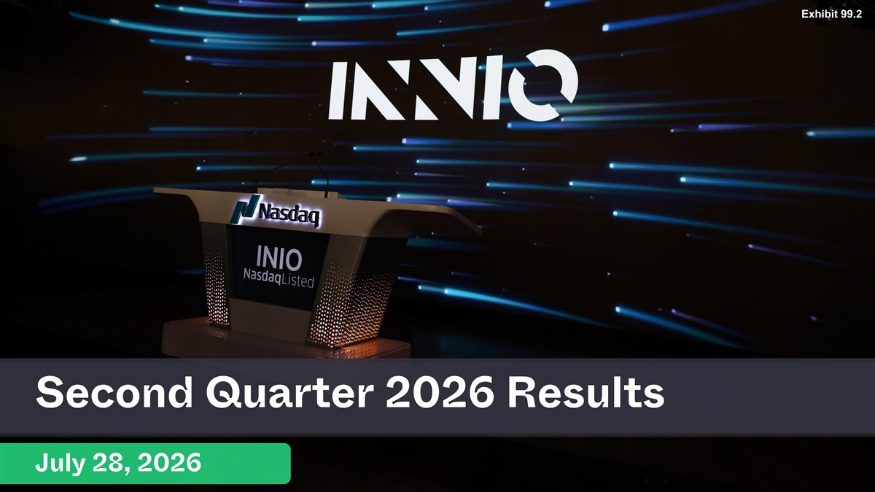
31 Exhibit 99.2 Text 31 39 230 Background 231 234 36 Accents 1 219 130 0 2 49 166 77 3 130 255 110 4 38 154 201 5 153 230 132 6 132 158 140 Hyperlink 87 255 81 Followed 2 Hyperlink 255 27 INNIO Green 164 (Darker for text ) 98 211 Second Quarter 2026 Results INNIO Red 32 8 255 INNIO Yellow 241 92 0 July 28, 2026 INNIO Cyan 181 213

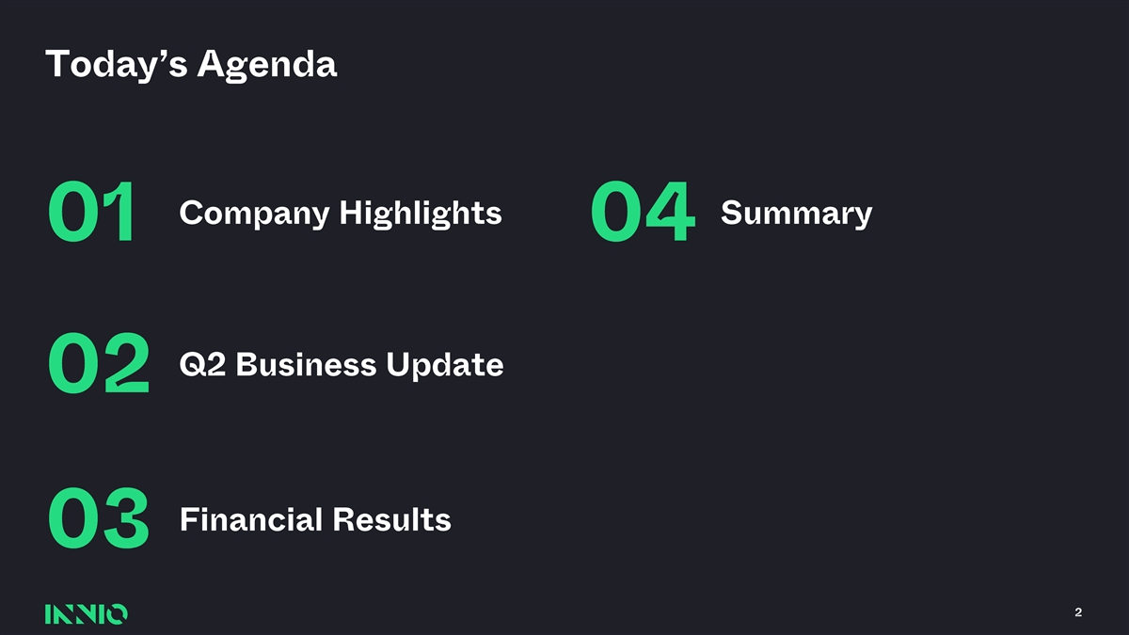
Today’s Agenda Company Highlights Summary 01 04 Q2 Business Update 02 Financial Results 03 2

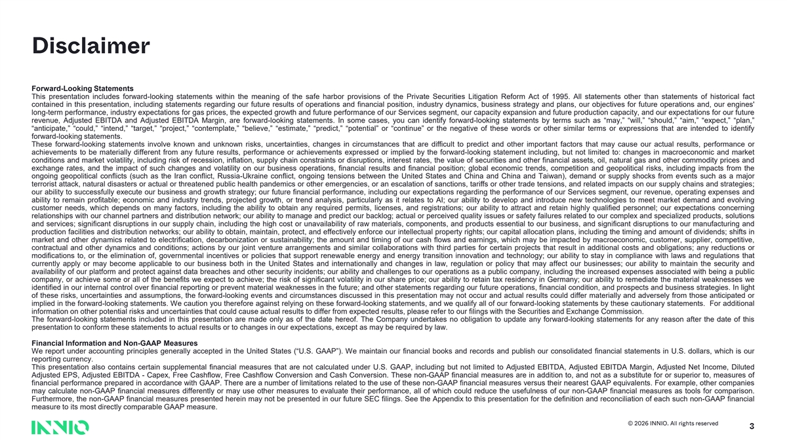
Disclaimer Forward-LookingStatements This presentation includes forward-looking statements within the meaning of the safe harbor provisions of the Private Securities Litigation Reform Act of 1995. All statements other than statements of historical fact contained in this presentation, including statements regarding our future results of operations and financial position, industry dynamics, business strategy and plans, our objectives for future operations and, our engines' long-term performance, industry expectations for gas prices, the expected growth and future performance of our Services segment, our capacity expansion and future production capacity, and our expectations for our future revenue, Adjusted EBITDA and Adjusted EBITDA Margin, are forward-looking statements. In some cases, you can identify forward-looking statements by terms such as“may,”“will,”“should,”“aim,”“expect,”“plan,” “anticipate,”“could,”“intend,”“target,”“project,”“contemplate,”“believe,”“estimate,”“predict,”“potential” or“continue” or the negative of these words or other similar terms or expressions that are intended to identify forward-lookingstatements. These forward-looking statements involve known and unknown risks, uncertainties, changes in circumstances that are difficult to predict and other important factors that may cause our actual results, performance or achievements to be materially different from any future results, performance or achievements expressed or implied by the forward-looking statement including, but not limited to: changes in macroeconomic and market conditions and market volatility, including risk of recession, inflation, supply chain constraints or disruptions, interest rates, the value of securities and other financial assets, oil, natural gas and other commodity prices and exchange rates, and the impact of such changes and volatility on our business operations, financial results and financial position; global economic trends, competition and geopolitical risks, including impacts from the ongoing geopolitical conflicts (such as the Iran conflict, Russia-Ukraine conflict, ongoing tensions between the United States and China and China and Taiwan), demand or supply shocks from events such as a major terrorist attack, natural disasters or actual or threatened public health pandemics or other emergencies, or an escalation of sanctions, tariffs or other trade tensions, and related impacts on our supply chains and strategies; our ability to successfully execute our business and growth strategy; our future financial performance, including our expectations regarding the performance of our Services segment, our revenue, operating expenses and ability to remain profitable; economic and industry trends, projected growth, or trend analysis, particularly as it relates to AI; our ability to develop and introduce new technologies to meet market demand and evolving customer needs, which depends on many factors, including the ability to obtain any required permits, licenses, and registrations; our ability to attract and retain highly qualified personnel; our expectations concerning relationships with our channel partners and distribution network; our ability to manage and predict our backlog; actual or perceived quality issues or safety failures related to our complex and specialized products, solutions and services; significant disruptions in our supply chain, including the high cost or unavailability of raw materials, components, and products essential to our business, and significant disruptions to our manufacturing and production facilities and distribution networks; our ability to obtain, maintain, protect, and effectively enforce our intellectual property rights; our capital allocation plans, including the timing and amount of dividends; shifts in market and other dynamics related to electrification, decarbonization or sustainability; the amount and timing of our cash flows and earnings, which may be impacted by macroeconomic, customer, supplier, competitive, contractual and other dynamics and conditions; actions by our joint venture arrangements and similar collaborations with third parties for certain projects that result in additional costs and obligations; any reductions or modifications to, or the elimination of, governmental incentives or policies that support renewable energy and energy transition innovation and technology; our ability to stay in compliance with laws and regulations that currently apply or may become applicable to our business both in the United States and internationally and changes in law, regulation or policy that may affect our businesses; our ability to maintain the security and availability of our platform and protect against data breaches and other security incidents; our ability and challenges to our operations as a public company, including the increased expenses associated with being a public company, or achieve some or all of the benefits we expect to achieve; the risk of significant volatility in our share price; our ability to retain tax residency in Germany; our ability to remediate the material weaknesses we identified in our internal control over financial reporting or prevent material weaknesses in the future; and other statements regarding our future operations, financial condition, and prospects and business strategies. In light of these risks, uncertainties and assumptions, the forward-looking events and circumstances discussed in this presentation may not occur and actual results could differ materially and adversely from those anticipated or implied in the forward-looking statements. We caution you therefore against relying on these forward-looking statements, and we qualify all of our forward-looking statements by these cautionary statements. For additional informationon otherpotential risksand uncertaintiesthat couldcauseactual results to differfrom expected results,pleaserefer to our filingswith the SecuritiesandExchange Commission. The forward-looking statements included in this presentation are made only as of the date hereof. The Company undertakes no obligation to update any forward-looking statements for any reason after the date of this presentationto conformthesestatementsto actual results or to changesin our expectations, except as may be required by law. FinancialInformationandNon-GAAP Measures We report under accounting principles generally accepted in the United States(“U.S.GAAP”). We maintain our financial books and records and publish our consolidated financial statements in U.S. dollars, which is our reporting currency. This presentation also contains certain supplemental financial measures that are not calculated under U.S. GAAP, including but not limited to Adjusted EBITDA, Adjusted EBITDA Margin, Adjusted Net Income, Diluted Adjusted EPS, Adjusted EBITDA - Capex, Free Cashflow, Free Cashflow Conversion and Cash Conversion. These non-GAAP financial measures are in addition to, and not as a substitute for or superior to, measures of financial performance prepared in accordance with GAAP. There are a number of limitations related to the use of these non-GAAP financial measures versus their nearest GAAP equivalents. For example, other companies may calculate non-GAAP financial measures differently or may use other measures to evaluate their performance, all of which could reduce the usefulness of our non-GAAP financial measures as tools for comparison. Furthermore, the non-GAAP financial measures presented herein may not be presented in our future SEC filings. See the Appendix to this presentation for the definition and reconciliation of each such non-GAAP financial measureto its mostdirectlycomparableGAAP measure. © 2026 INNIO. All rights reserved 3

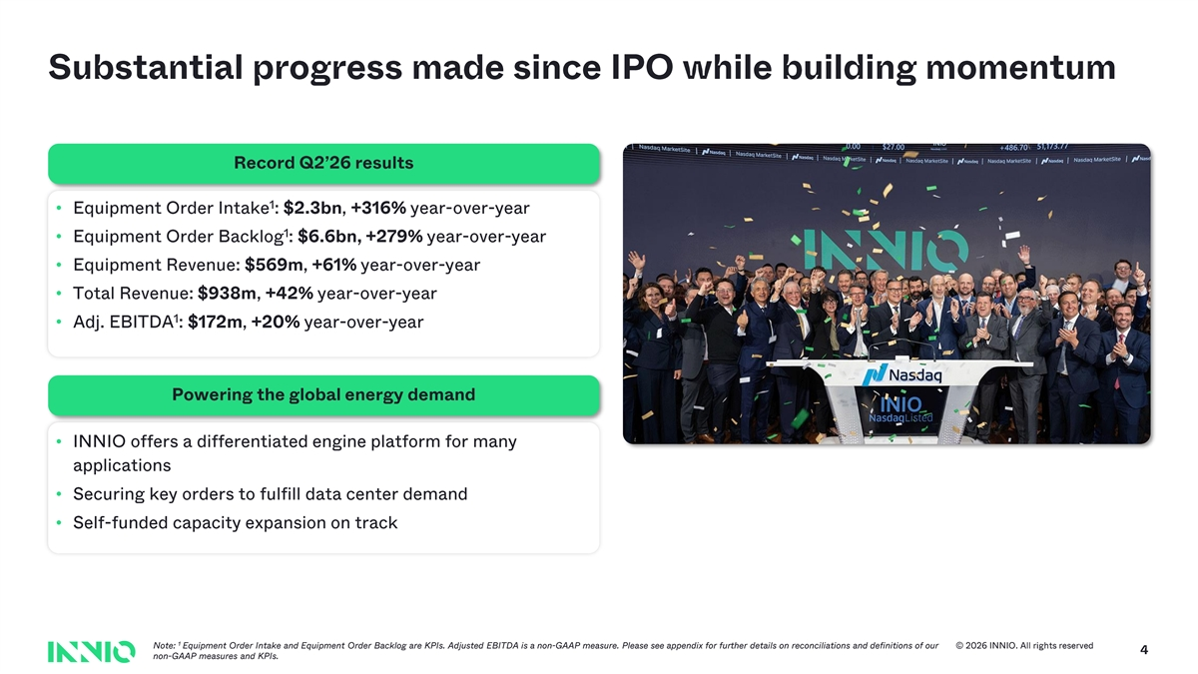
Substantial progress made since IPO while building momentum Record Q2’26 results 1 • Equipment Order Intake : $2.3bn , +316% year - over -year 1 • Equipment Order Backlog : $6.6bn, +279% year - over -year • Equipment Revenue: $569m , +61% year - over -year • Total Revenue: $938m , +42% year - over -year 1 • Adj. EBITDA : $172m , +20% year - over -year Powering the global energy demand • INNIO offers a differentiated engine platform for many applications • Securing key orders to fulfill data center demand • Self - funded capacity expansion on track 1 Note: Equipment Order Intake and Equipment Order Backlog are KPIs. Adjusted EBITDA is a non - GAAP measure. Please see appendix for fur ther details on reconciliations and definitions of our © 2026 INNIO. All rights reserved 4 non - GAAP measures and KPIs.


31 Text 31 39 230 Background 231 Company Highlights 234 36 Accents 1 219 130 0 2 49 166 77 3 130 255 110 4 38 154 201 5 153 230 132 6 132 01 158 140 Hyperlink 87 255 81 Followed 2 Hyperlink 255 27 INNIO Green 164 (Darker for text ) 98 211 INNIO Red 32 8 255 INNIO Yellow 241 92 0 5 INNIO Cyan 181 213

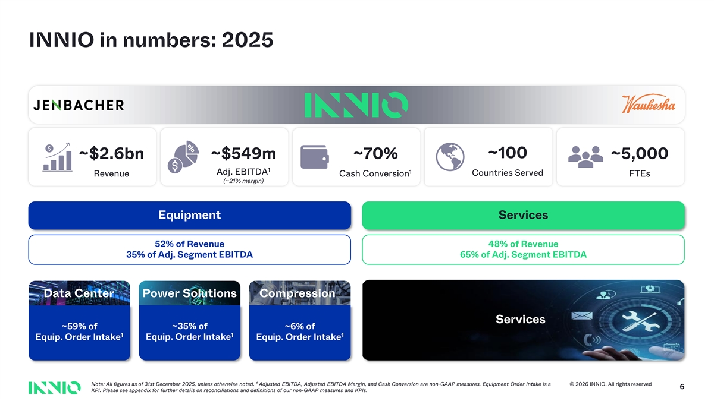
INNIO in numbers: 2025 ~100 ~$2.6bn ~$549m ~70% ~ 5,000 1 1 Adj. EBITDA Countries Served Revenue Cash Conversion FTEs (~21% margin) Equipment Services 52% of Revenue 48% of Revenue 35% of Adj. Segment EBITDA 65% of Adj. Segment EBITDA Data Center Power Solutions Compression Services ~59% of ~35% of ~6% of 1 1 1 Equip. Order Intake Equip. Order Intake Equip. Order Intake 1 Note: All figures as of 31st December 2025, unless otherwise noted. Adjusted EBITDA, Adjusted EBITDA Margin, and Cash Conversion are non - GAAP measures. Equipment Order Intake is a © 2026 INNIO. All rights reserved 6 KPI. Please see appendix for further details on reconciliations and definitions of our non - GAAP measures and KPIs.

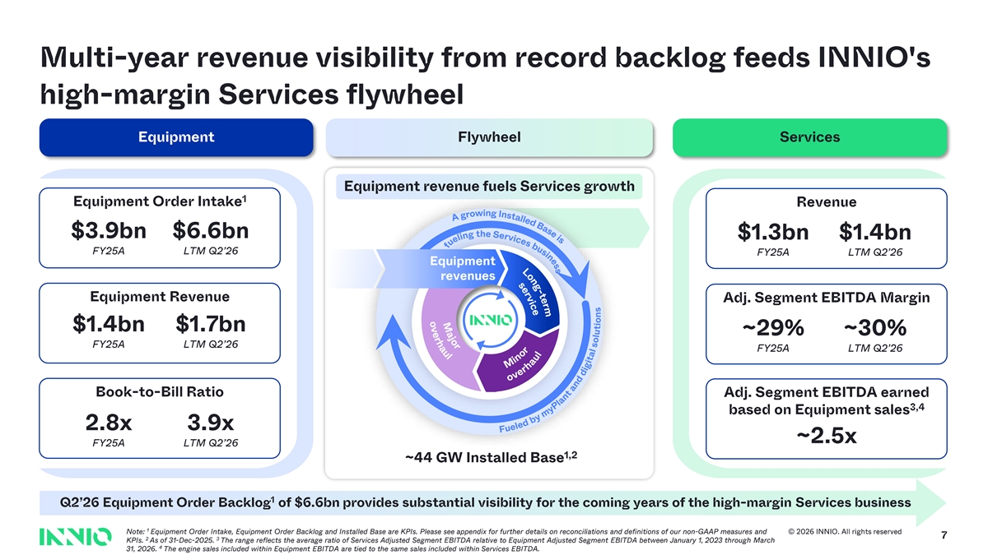
s o m v r e M e e c r i s t a v - h j r g e o a n s e r u o l L n s i i s e s u a b B s d e e l c l i a v t r s e n S I g e n h Multi - year revenue visibility from record backlog feeds INNIO's high - margin Services flywheel Equipment Flywheel Services Equipment revenue fuels Services growth 1 Equipment Order Intake Revenue $ 3.9 bn $6.6bn $ 1.3bn $1.4bn FY25A LTM Q2’26 FY25A LTM Q2’26 Equipment revenues Equipment Revenue Adj. Segment EBITDA Margin $ 1.4bn $ 1.7bn ~29% ~30% FY25A LTM Q2’26 FY25A LTM Q2’26 Book - to - Bill Ratio Adj. Segment EBITDA earned 3,4 based on Equipment sales 2.8x 3.9x ~2.5x FY25A LTM Q2’26 1,2 ~44 GW Installed Base 1 Q2’26 Equipment Order Backlog of $6.6bn provides substantial visibility for the coming years of the high - margin Services business 1 Note: Equipment Order Intake, Equipment Order Backlog and Installed Base are KPIs. Please see appendix for further details on recon cil iations and definitions of our non - GAAP measures and © 2026 INNIO. All rights reserved 7 2 3 KPIs. As of 31 - Dec - 2025. The range reflects the average ratio of Services Adjusted Segment EBITDA relative to Equipment Adjusted Segment EBITDA betwee n J anuary 1, 2023 through March 4 31, 2026. The engine sales included within Equipment EBITDA are tied to the same sales included within Services EBITDA. i t w o g r F g u n e l i A e l d o b e v y M m e i y r P n u l h a o n a t r a u n f d l d i g i t a l s o l u t i o n s

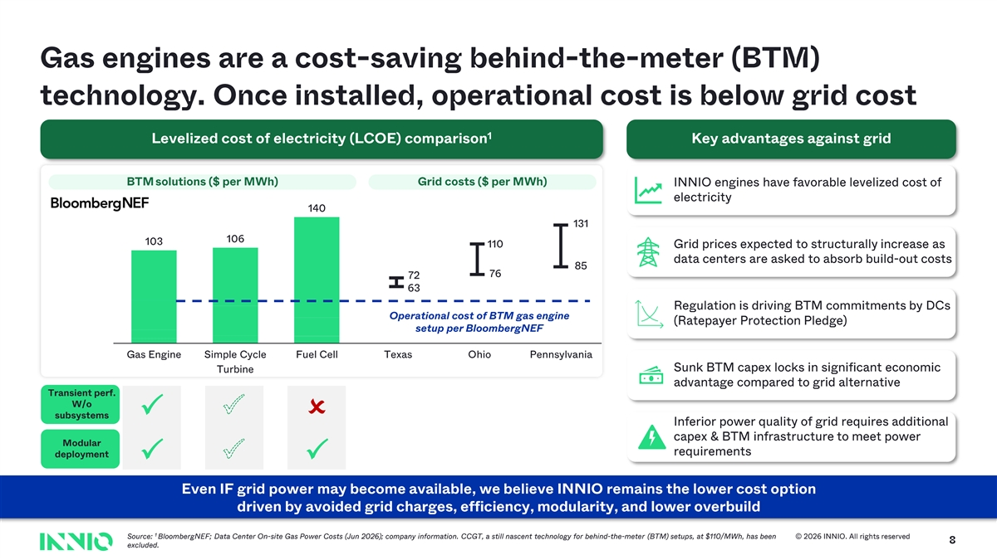
Gas engines are a cost - saving behind - the - meter (BTM) technology. Once installed, operational cost is below grid cost 1 Levelized cost of electricity (LCOE) comparison Key advantages against grid BTM solutions ($ per MWh) Grid costs ($ per MWh) INNIO engines have favorable levelized cost of electricity 140 131 106 103 110 Grid prices expected to structurally increase as data centers are asked to absorb build - out costs 85 76 72 63 Regulation is driving BTM commitments by DCs Operational cost of BTM gas engine (Ratepayer Protection Pledge) setup per BloombergNEF Gas Engine Simple Cycle Fuel Cell Texas Ohio Pennsylvania Sunk BTM capex locks in significant economic Turbine advantage compared to grid alternative Transient perf. W/o subsystemsPPO Inferior power quality of grid requires additional capex & BTM infrastructure to meet power Modular requirements deployment PPP Even IF grid power may become available, we believe INNIO remains the lower cost option driven by avoided grid charges, efficiency, modularity, and lower overbuild 1 Source: BloombergNEF ; Data Center On - site Gas Power Costs (Jun 2026) ; company information. CCGT, a still nascent technology for behind - the - meter ( BTM) setups, at $110/MWh, has been © 2026 INNIO. All rights reserved 1 excluded.


31 Text 31 39 Q2 2026 230 Background 231 234 Business Update 36 Accents 1 219 130 0 2 49 166 77 3 130 255 110 4 38 154 201 5 153 230 132 6 132 02 158 140 Hyperlink 87 255 81 Followed 2 Hyperlink 255 27 INNIO Green 164 (Darker for text ) 98 211 INNIO Red 32 8 255 INNIO Yellow 241 92 0 9 INNIO Cyan 181 213

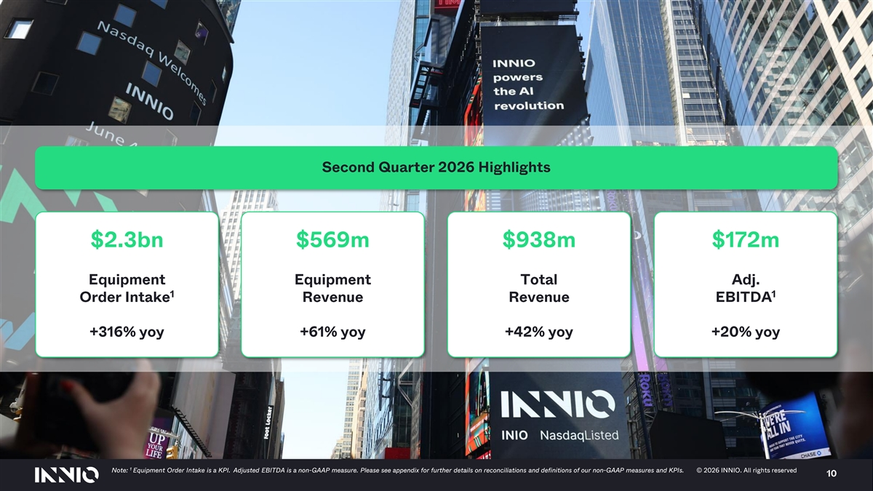
Second Quarter 2026 Highlights $2.3bn $569m $938m $172m Equipment Equipment Total Adj. 1 1 Order Intake Revenue Revenue EBITDA +316% yoy +61% yoy +42% yoy +20% yoy 1 Note: Equipment Order Intake is a KPI. Adjusted EBITDA is a non - GAAP measure. Please see appendix for further details on reconciliations and definitions of our non - GAA P measures and KPIs. © 2026 INNIO. All rights reserved © 2026 INNIO. All rights reserved 10

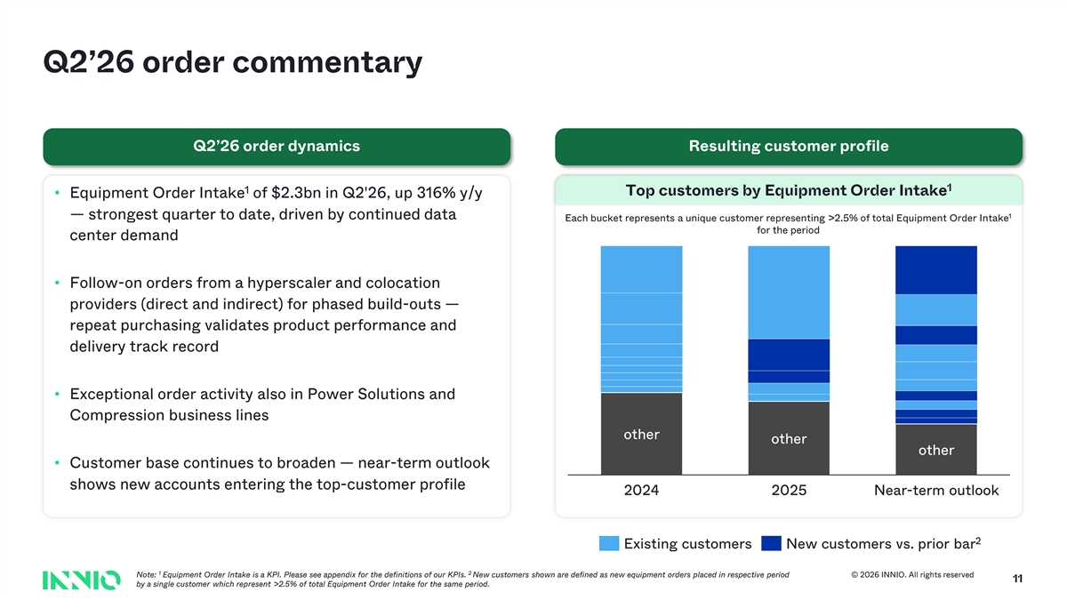
Q2’26 order commentary Q2’26 order dynamics Resulting customer profile 1 1 Top customers by Equipment Order Intake • Equipment Order Intake of $2.3bn in Q2'26, up 316% y/y 1 — strongest quarter to date, driven by continued data Each bucket represents a unique customer representing >2.5% of total Equipment Order Intake for the period center demand • Follow - on orders from a hyperscaler and colocation providers (direct and indirect) for phased build - outs — repeat purchasing validates product performance and delivery track record • Exceptional order activity also in Power Solutions and Compression business lines other other Other other • Customer base continues to broaden — near - term outlook shows new accounts entering the top - customer profile 2024 2025 Near - term outlook 2 Existing customers New customers vs. prior bar 1 2 Note: Equipment Order Intake is a KPI. Please see appendix for the definitions of our KPIs. New customers shown are defined as new equipment orders placed in respective period © 2026 INNIO. All rights reserved 11 by a single customer which represent >2.5% of total Equipment Order Intake for the same period.

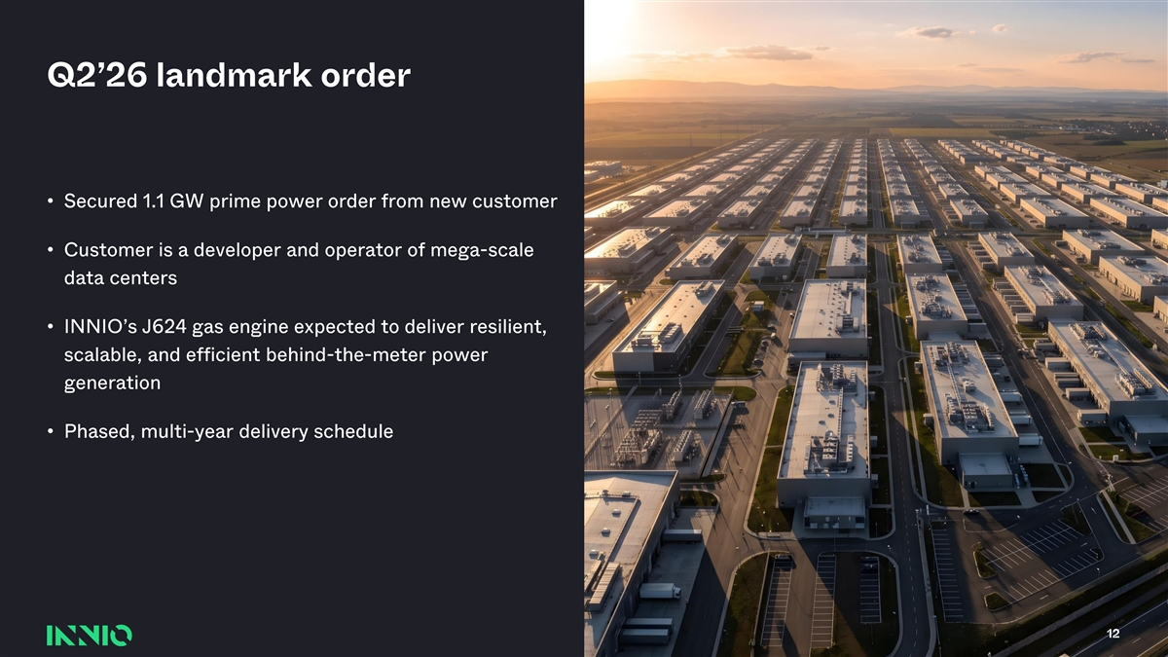
31 Text 31 39 230 Background 231 Q2’26 landmark order 234 36 Accents 1 219 130 0 2 49 166 77 • Secured 1.1 GW prime power order from new customer 3 130 255 110 • Customer is a developer and operator of mega - scale 4 38 154 data centers 201 5 153 230 • INNIO’s J624 gas engine expected to deliver resilient, 132 6 132 scalable, and efficient behind - the - meter power 158 generation 140 Hyperlink 87 255 81• Phased, multi - year delivery schedule Followed 2 Hyperlink 255 27 INNIO Green 164 (Darker for text ) 98 211 INNIO Red 32 8 255 INNIO Yellow 241 92 0 12 INNIO Cyan 181 213


31 Text 31 39 230 Background 231 Financial Results 234 36 Accents 1 219 130 0 2 49 166 77 3 130 255 110 4 38 154 201 5 153 230 132 6 132 03 158 140 Hyperlink 87 255 81 Followed 2 Hyperlink 255 27 INNIO Green 164 (Darker for text ) 98 211 INNIO Red 32 8 255 INNIO Yellow 241 92 0 13 INNIO Cyan 181 213

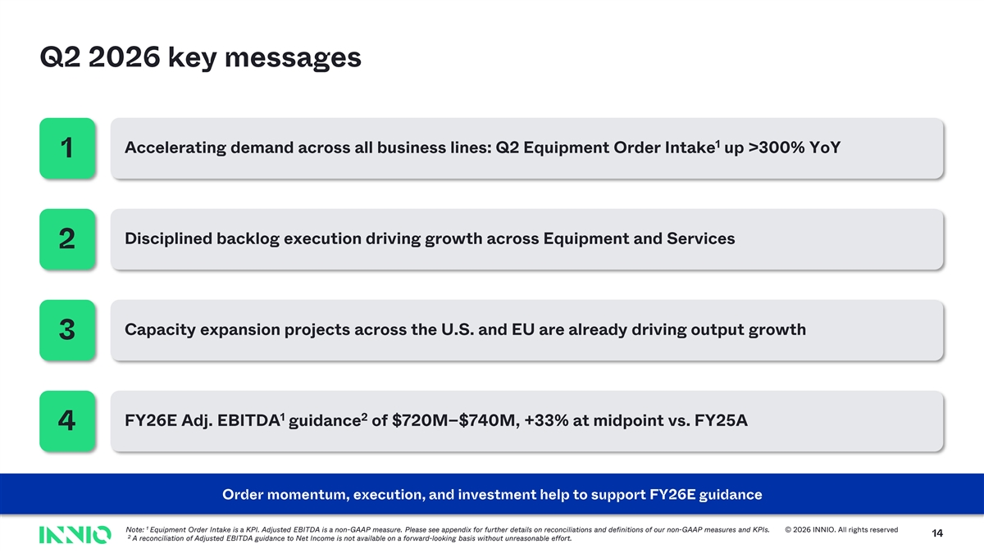
Q2 2026 key messages 1 Accelerating demand across all business lines: Q2 Equipment Order Intake up >300% YoY 1 Disciplined backlog execution driving growth across Equipment and Services 2 Capacity expansion projects across the U.S. and EU are already driving output growth 3 1 2 FY26E Adj. EBITDA guidance of $720M – $740M, +33% at midpoint vs. FY25A 4 Order momentum, execution, and investment help to support FY26E guidance 1 Note: Equipment Order Intake is a KPI. Adjusted EBITDA is a non - GAAP measure. Please see appendix for further details on reconciliatio ns and definitions of our non - GAAP measures and KPIs. © 2026 INNIO. All rights reserved 14 2 A reconciliation of Adjusted EBITDA guidance to Net Income is not available on a forward - looking basis without unreasonable effo rt.

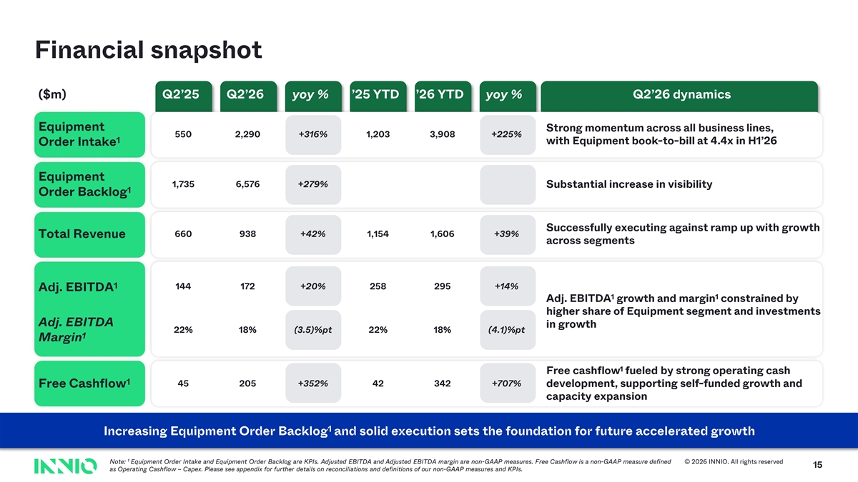
Financial snapshot ($m) Q2’25 Q2’26 yoy % ’25 YTD ’26 YTD yoy % Q2’26 dynamics Equipment Strong momentum across all business lines, 550 2,290 +316% 1,203 3,908 +225% 1 with Equipment book - to - bill at 4.4x in H1’26 Order Intake Equipment 1,735 6,576 +279% Substantial increase in visibility 1 Order Backlog Successfully executing against ramp up with growth 660 938 +42% 1,154 1,606 +39% Total Revenue across segments 1 144 172 +20% 258 295 +14% Adj. EBITDA 1 1 Adj. EBITDA growth and margin constrained by higher share of Equipment segment and investments Adj. EBITDA in growth 22% 18% (3.5)%pt 22% 18% (4.1)% pt 1 Margin 1 Free cashflow fueled by strong operating cash 1 45 205 +352% 42 342 +707% Free Cashflow development, supporting self - funded growth and capacity expansion 1 Increasing Equipment Order Backlog and solid execution sets the foundation for future accelerated growth 1 Note: Equipment Order Intake and Equipment Order Backlog are KPIs. Adjusted EBITDA and Adjusted EBITDA margin are non - GAAP measures. Free Cashflow is a non - GAAP measure defined © 2026 INNIO. All rights reserved 15 as Operating Cashflow – Capex. Please see appendix for further details on reconciliations and definitions of our non - GAAP measures and KPIs.

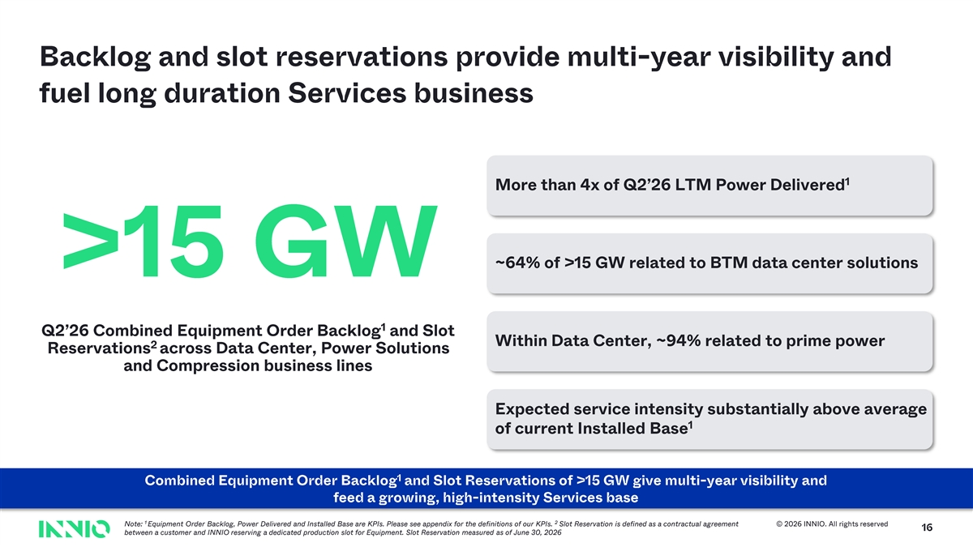
Backlog and slot reservations provide multi - year visibility and fuel long duration Services business 1 More than 4x of Q2’26 LTM Power Delivered ~64% of >15 GW related to BTM data center solutions >15 GW 1 Q2’26 Combined Equipment Order Backlog and Slot Within Data Center, ~94% related to prime power 2 Reservations across Data Center, Power Solutions and Compression business lines Expected service intensity substantially above average 1 of current Installed Base 1 Combined Equipment Order Backlog and Slot Reservations of >15 GW give multi - year visibility and feed a growing, high - intensity Services base 1 2 Note: Equipment Order Backlog, Power Delivered and Installed Base are KPIs. Please see appendix for the definitions of our KPIs. Slot Reservation is defined as a contractual agreement © 2026 INNIO. All rights reserved 16 between a customer and INNIO reserving a dedicated production slot for Equipment. Slot Reservation measured as of June 30, 2026

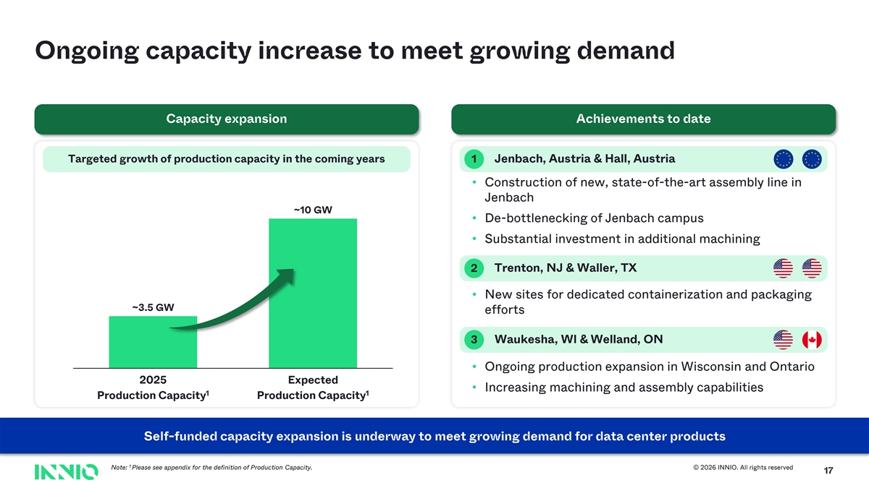
Ongoing capacity increase to meet growing demand Capacity expansion Achievements to date Targeted growth of production capacity in the coming years 1 Jenbach , Austria & Hall, Austria • Construction of new, state - of-the -art assembly line in Jenbach ~10 GW • De - bottlenecking of Jenbach campus • Substantial investment in additional machining 2 Trenton, NJ & Waller, TX • New sites for dedicated containerization and packaging ~3.5 GW efforts 3 Waukesha, WI & Welland , ON • Ongoing production expansion in Wisconsin and Ontario 2025 Expected • Increasing machining and assembly capabilities 1 1 Production Capacity Production Capacity Self - funded capacity expansion is underway to meet growing demand for data center products 1 Note: Please see appendix for the definition of Production Capacity. © 2026 INNIO. All rights reserved 17

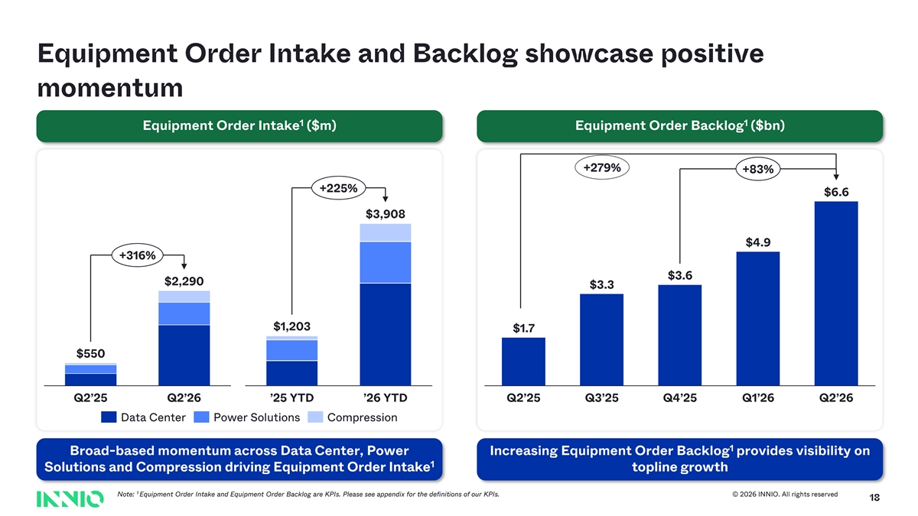
Equipment Order Intake and Backlog showcase positive momentum 1 1 Equipment Order Intake ($m) Equipment Order Backlog ($bn) +279% +83% +225% $6.6 $3,908 $4.9 +316% $3.6 $2,290 $3.3 $1,203 $1.7 $550 Q2’25 Q2’26 ’25 YTD ’26 YTD Q2’25 Q3’25 Q4’25 Q1’26 Q2’26 Data Center Power Solutions Compression 1 Broad - based momentum across Data Center , Power Increasing Equipment Order Backlog provides visibility on 1 Solutions and Compression driving Equipment Order Intake topline growth 1 No te : Equipment Order Intake and Equipment Order Backlog are KPIs. Please see appendix for the definitions of our KPIs. © 2026 INNIO. All rights reserved 18

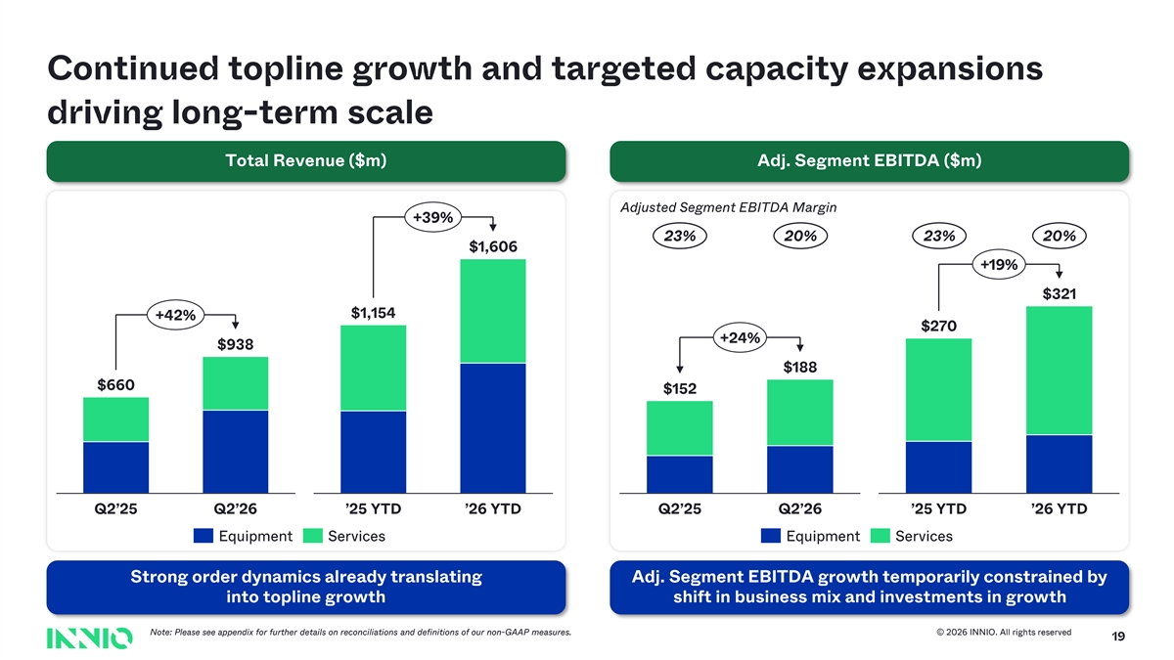
Continued topline growth and targeted capacity expansions driving long - term scale Total Revenue ($m) Adj. Segment EBITDA ($m) Adjusted Segment EBITDA Margin +39% 23% 20 % 23% 20% $1,606 +19% $321 $1,154 +42% $ 270 +24% $938 $188 $660 $152 Q2’25 Q2’26 ’25 YTD ’26 YTD Q2’25 Q2’26 ’25 YTD ’26 YTD Equipment Services Equipment Services Strong order dynamics already translating Adj. Segment EBITDA growth temporarily constrained by into topline growth shift in business mix and investments in growth Note: P lease see appendix for further details on reconciliations and definitions of our non - GAAP measures. © 2026 INNIO. All rights reserved 19

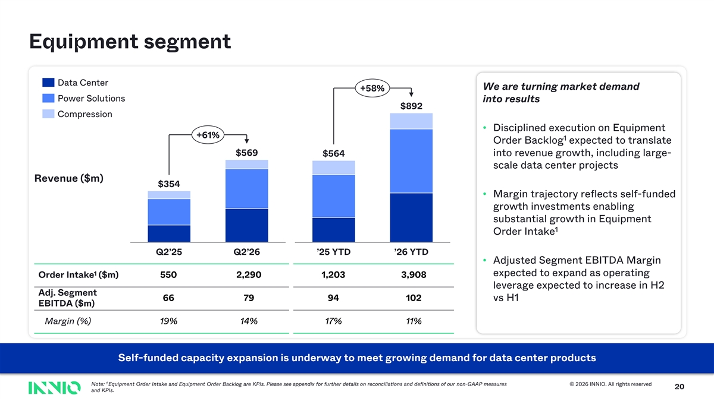
Equipment segment Data Center We are turning market demand +58% Power Solutions into results $892 Compression • Disciplined execution on Equipment +61% 1 Order Backlog expected to translate $569 $564 into revenue growth, including large - scale data center projects Revenue ($m) $354 • Margin trajectory reflects self - funded growth investments enabling substantial growth in Equipment 1 Order Intake Q2’25 Q2’26 ’25 YTD ’26 YTD • Adjusted Segment EBITDA Margin 1 expected to expand as operating Order Intake ($m) 550 2,290 1,203 3,908 leverage expected to increase in H2 Adj. Segment 66 79 94 102 vs H1 EBITDA ($m) Margin (%) 19% 14% 17% 11% Self - funded capacity expansion is underway to meet growing demand for data center products 1 Note: Equipment Order Intake and Equipment Order Backlog are KPIs. Please see appendix for further details on reconciliations and definitions of our non - GAAP measures © 2026 INNIO. All rights reserved 20 and KPIs.

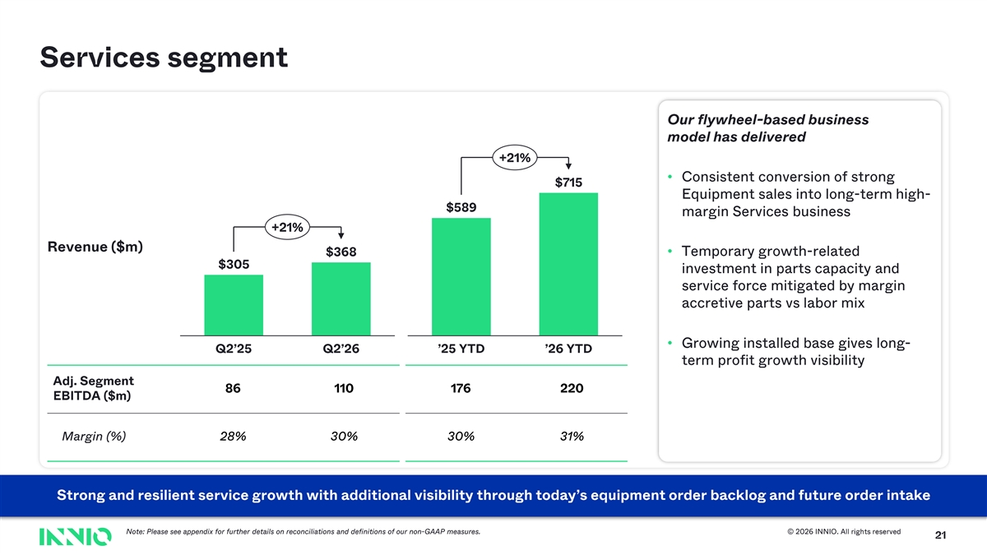
Services segment Our flywheel - based business model has delivered +21% • Consistent conversion of strong $715 Equipment sales into long - term high - $589 margin Services business +21% Revenue ($m) $368• Temporary growth - related $305 investment in parts capacity and service force mitigated by margin accretive parts vs labor mix • Growing installed base gives long - Q2’25 Q2’26 ’25 YTD ’26 YTD term profit growth visibility Adj. Segment 86 110 176 220 EBITDA ($m) Margin (%) 28% 30% 30% 31% Strong and resilient service growth with additional visibility through today’s equipment order backlog and future order intak e Note: Please see appendix for further details on reconciliations and definitions of our non - GAAP measures. © 2026 INNIO. All rights reserved 21

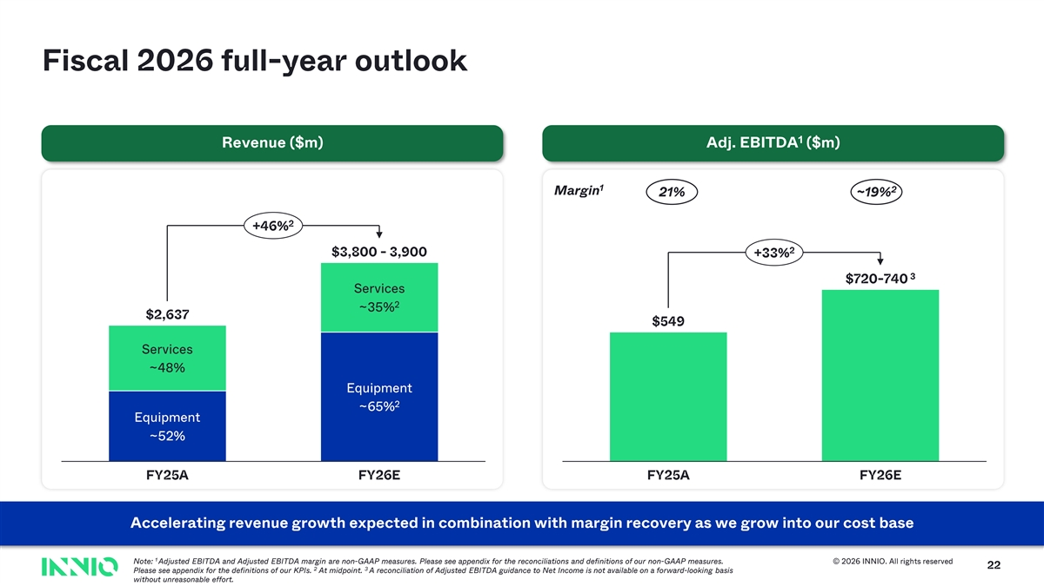
Fiscal 2026 full - year outlook 1 Revenue ($m) Adj. EBITDA ($m) 1 2 Margin 21% ~19 % 2 +46% 2 $3,800 - 3,900 +33% 3 $720 - 740 Services 2 ~35% $ 2,637 $549 Services ~48% Equipment 2 ~65% Equipment ~52% FY25 A FY26 E FY25 A FY26 E Accelerating revenue growth expected in combination with margin recovery as we grow into our cost base 1 Note: Adjusted EBITDA and Adjusted EBITDA margin are non - GAAP measures. Please see appendix for the reconciliations and definitions of our non - GAAP measures. © 2026 INNIO. All rights reserved 22 2 3 Please see appendix for the definitions of our KPIs. At midpoint. A reconciliation of Adjusted EBITDA guidance to Net Income is not available on a forward - looking basis without unreasonable effort.


31 Text 31 39 230 Background 231 Summary 234 36 Accents 1 219 130 0 2 49 166 77 3 130 255 110 4 38 154 201 5 153 230 132 6 132 04 158 140 Hyperlink 87 255 81 Followed 2 Hyperlink 255 27 INNIO Green 164 (Darker for text ) 98 211 INNIO Red 32 8 255 INNIO Yellow 241 92 0 23 INNIO Cyan 181 213

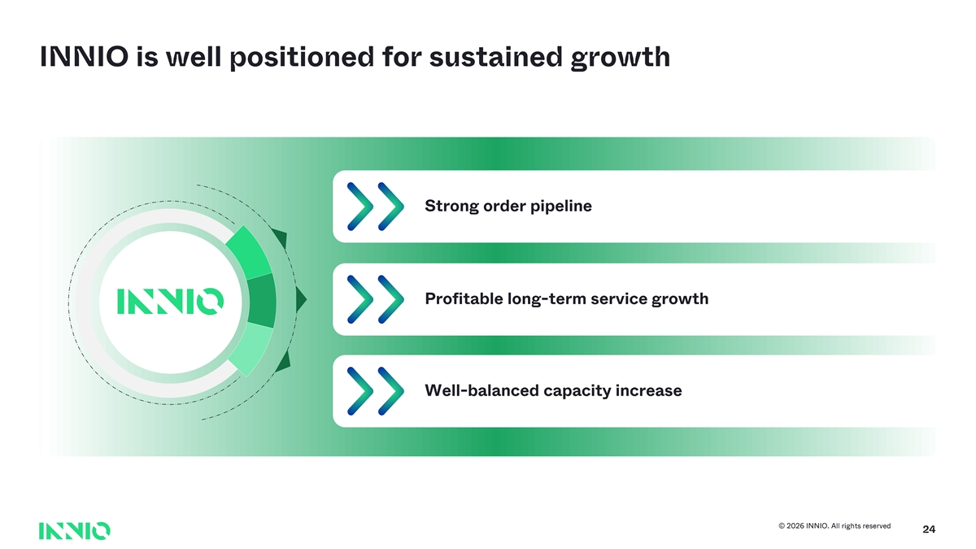
INNIO is well positioned for sustained growth Strong order pipeline Text Profitable long - term service growth Well - balanced capacity increase © 2026 INNIO. All rights reserved 24


31 Text 31 39 230 Background 231 234 36 Accents 1 219 130 0 2 49 166 77 3 130 255 110 4 38 154 201 5 153 Q&A 230 132 6 132 158 140 Hyperlink 87 255 81 Followed 2 Hyperlink 255 27 INNIO Green 164 (Darker for text ) 98 211 INNIO Red 32 8 255 INNIO Yellow 241 92 0 25 INNIO Cyan 181 213


31 Text 31 39 230 Background 231 234 36 Accents 1 219 130 0 2 49 166 77 3 130 255 110 4 38 154 201 5 153 230 132 6 132 158 Appendix 140 Hyperlink 87 255 81 Followed 2 Hyperlink 255 27 INNIO Green 164 (Darker for text ) 98 211 INNIO Red 32 8 255 INNIO Yellow 241 92 0 26 INNIO Cyan 181 213

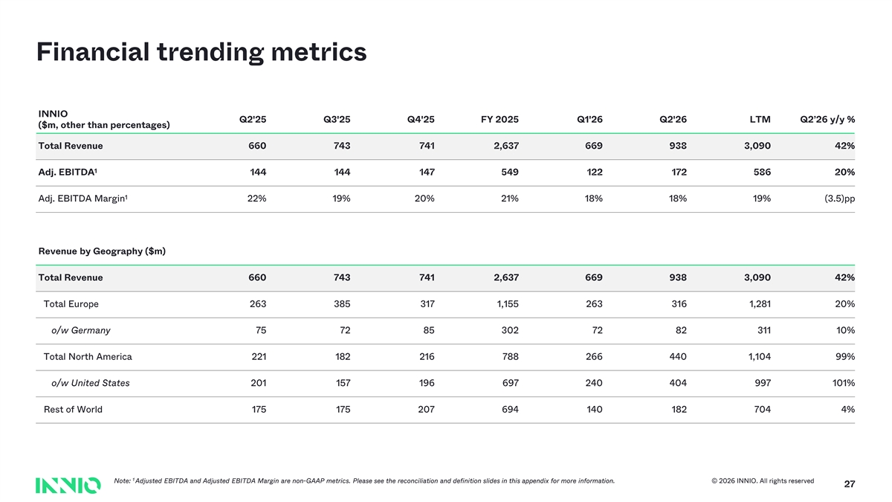
Financial trending metrics INNIO Q2'25 Q3'25 Q4'25 FY 2025 Q1'26 Q2'26 LTM Q2’26 y/y % ($m, other than percentages) Total Revenue 660 743 741 2,637 669 938 3,090 42% 1 Adj. EBITDA 144 144 147 549 122 172 586 20% 1 Adj. EBITDA Margin 22% 19% 20% 21% 18% 18% 19% (3.5)pp Revenue by Geography ($m) Total Revenue 660 743 741 2,637 669 938 3,090 42% Total Europe 263 385 317 1,155 263 316 1,281 20% o/w Germany 75 72 85 302 72 82 311 10% Total North America 221 182 216 788 266 440 1,104 99% o/w United States 201 157 196 697 240 404 997 101% Rest of World 175 175 207 694 140 182 704 4% 1 Note: Adjusted EBITDA and Adjusted EBITDA Margin are non - GAAP metrics. Please see the reconciliation and definition slides in this app endix for more information. © 2026 INNIO. All rights reserved 27

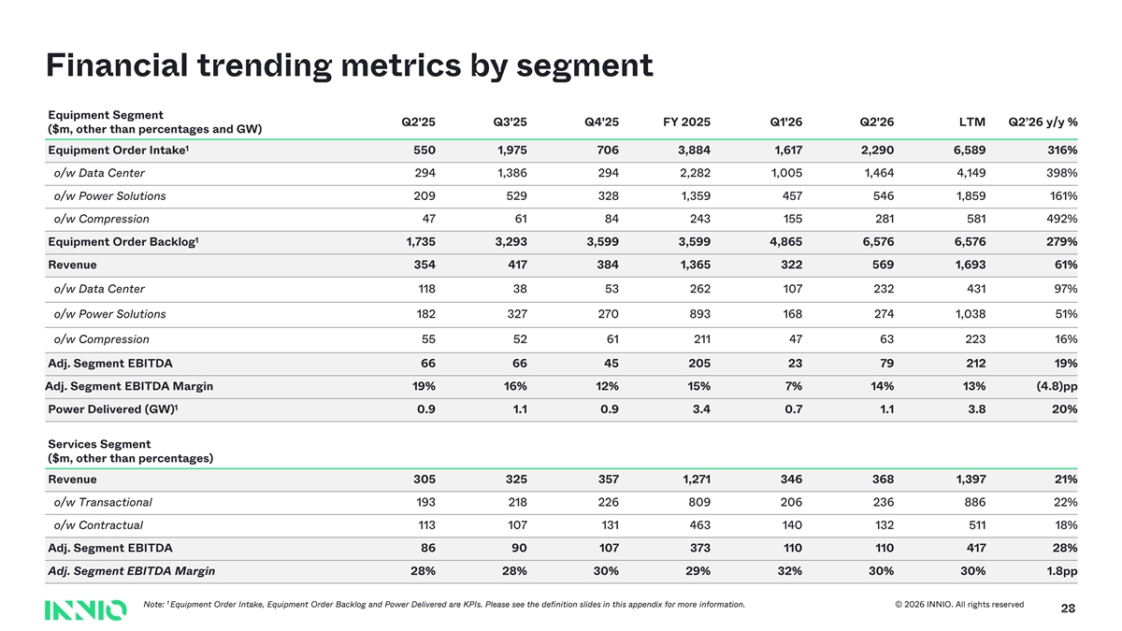
Financial trending metrics by segment Equipment Segment Q2'25 Q3'25 Q4'25 FY 2025 Q1'26 Q2'26 LTM Q2’26 y/y % ($m, other than percentages and GW) 1 Equipment Order Intake 550 1,975 706 3,884 1,617 2,290 6,589 316% o/w Data Center 294 1,386 294 2,282 1,005 1,464 4,149 398% o/w Power Solutions 209 529 328 1,359 457 546 1,859 161% o/w Compression 47 61 84 243 155 281 581 492% 1 Equipment Order Backlog 1,735 3,293 3,599 3,599 4,865 6,576 6,576 279% Revenue 354 417 384 1,365 322 569 1,693 61% o/w Data Center 118 38 53 262 107 232 431 97% o/w Power Solutions 182 327 270 893 168 274 1,038 51% o/w Compression 55 52 61 211 47 63 223 16% Adj. Segment EBITDA 66 66 45 205 23 79 212 19% Adj. Segment EBITDA Margin 19% 16% 12% 15% 7% 14% 13% (4.8)pp 1 Power Delivered (GW) 0.9 1.1 0.9 3.4 0.7 1.1 3.8 20% Services Segment ($m, other than percentages) Revenue 305 325 357 1,271 346 368 1,397 21% o/w Transactional 193 218 226 809 206 236 886 22% o/w Contractual 113 107 131 463 140 132 511 18% Adj. Segment EBITDA 86 90 107 373 110 110 417 28% Adj. Segment EBITDA Margin 28% 28% 30% 29% 32% 30% 30% 1.8pp 1 Note: Equipment Order Intake, Equipment Order Backlog and Power Delivered are KPIs. Please see the definition slides in this append ix for more information. © 2026 INNIO. All rights reserved 28

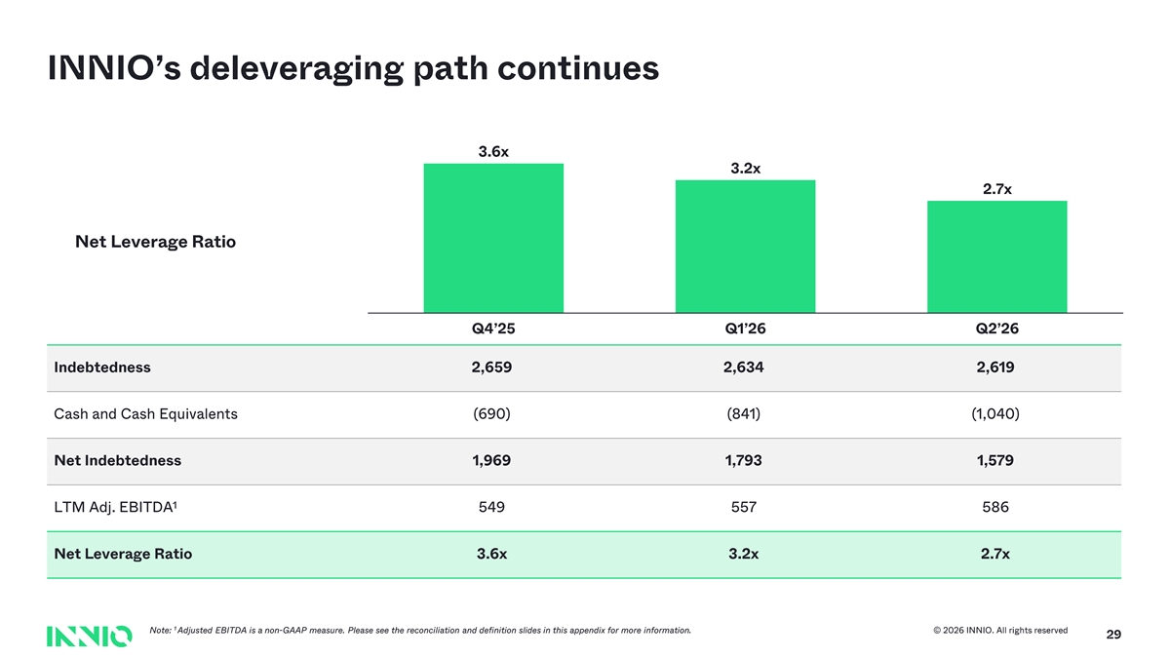
INNIO’s deleveraging path continues 3.6x 3.2x 2.7x Net Leverage Ratio Q4’25 Q1’26 Q2’26 Indebtedness 2,659 2,634 2,619 Cash and Cash Equivalents (690) (841) (1,040) Net Indebtedness 1,969 1,793 1,579 1 LTM Adj. EBITDA 549 557 586 Net Leverage Ratio 3.6x 3.2x 2.7x 1 Note: Adjusted EBITDA is a non - GAAP measure. Please see the reconciliation and definition slides in this appendix for more information . © 2026 INNIO. All rights reserved 29

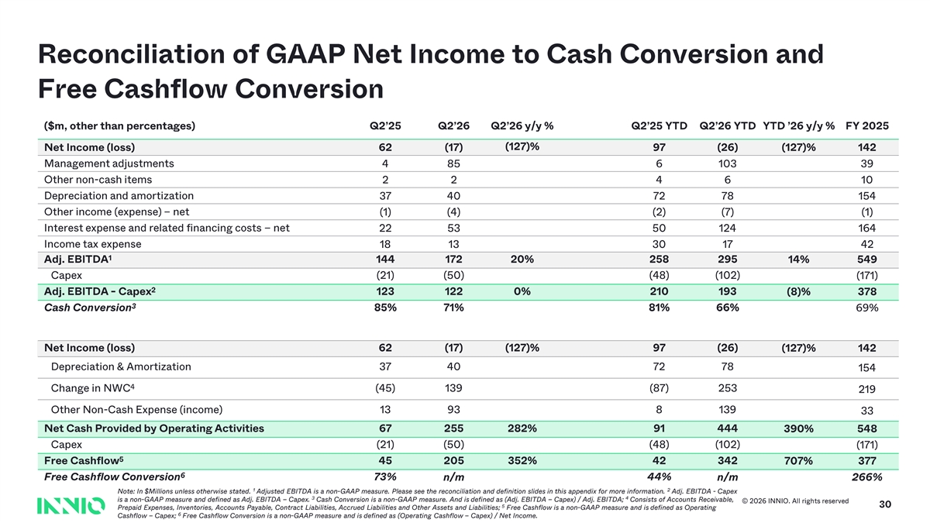
Reconciliation of GAAP Net Income to Cash Conversion and Free Cashflow Conversion ($m, other than percentages) Q2’25 Q2’26 Q2’26 y/y % Q2’25 YTD Q2’26 YTD YTD ’26 y/y % FY 2025 (127)% Net Income (loss) 62 (17) 97 (26) (127)% 142 Management adjustments 4 85 6 103 39 Other non - cash items 2 2 4 6 10 Depreciation and amortization 37 40 72 78 154 Other income (expense) – net (1) (4) (2) (7) (1) Interest expense and related financing costs – net 22 53 50 124 164 Income tax expense 18 13 30 17 42 1 Adj. EBITDA 144 172 20% 258 295 14% 549 Capex (21) (50) (48) (102) (171) 2 Adj. EBITDA - Capex 123 122 0% 210 193 (8)% 378 3 Cash Conversion 85% 71% 81% 66% 69% Net Income (loss) 62 (17) (127)% 97 (26) (127)% 142 Depreciation & Amortization 37 40 72 78 154 4 Change in NWC (45) 139 (87) 25 3 219 Other Non - Cash Expense (income) 13 93 8 139 33 Net Cash Provided by Operating Activities 67 255 282% 91 444 390 % 548 Capex (21) (50) (48) (102) (171) 5 Free Cashflow 45 205 352% 42 342 707% 377 6 Free Cashflow Conversion 73% n/m 44% n/m 266% 1 2 Note: In $Millions unless otherwise stated. Adjusted EBITDA is a non - GAAP measure. Please see the reconciliation and definition slides in this appendix for more information . Adj. EBITDA - Capex 3 4 is a non - GAAP measure and defined as Adj. EBITDA – Capex . Cash Conversion is a non - GAAP measure. And is defined as (Adj. EBITDA – Capex) / Adj. EBITDA; Consists of Accounts Receivable, © 2026 INNIO. All rights reserved 5 30 Prepaid Expenses, Inventories, Accounts Payable, Contract Liabilities, Accrued Liabilities and Other Assets and Liabilities; Free Cashflow is a non - GAAP measure and is defined as Operating 6 Cashflow – Capex; Free Cashflow Conversion is a non - GAAP measure and is defined as (Operating Cashflow – Capex) / Net Income.

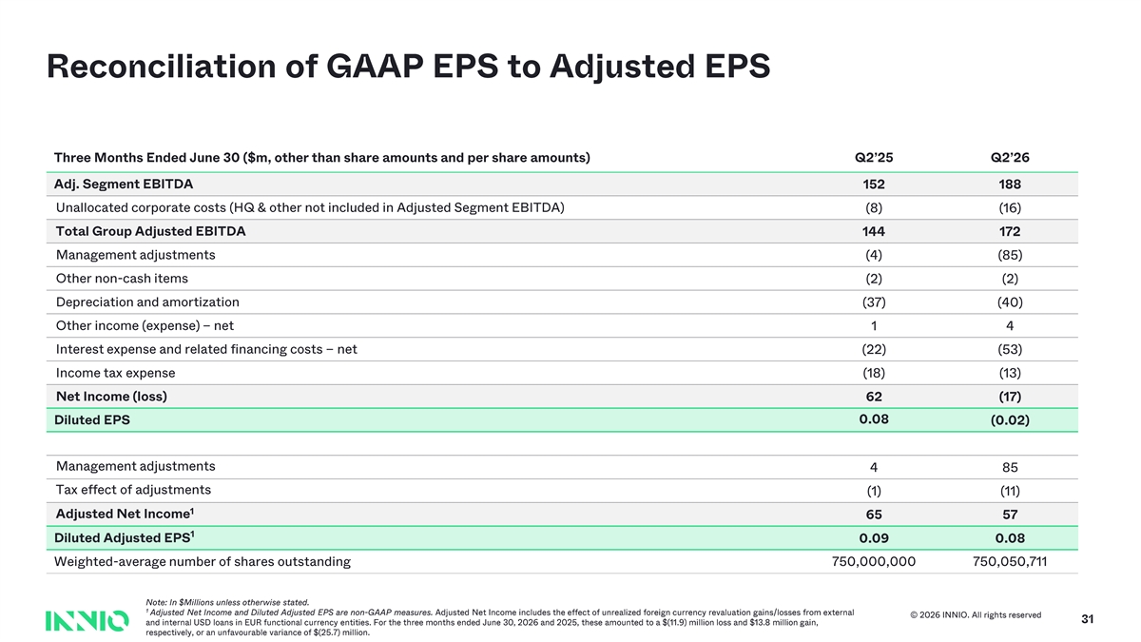
Reconciliation of GAAP EPS to Adjusted EPS Three Months Ended June 30 ($m, other than share amounts and per share amounts) Q2’25 Q2’26 Adj. Segment EBITDA 152 188 Unallocated corporate costs (HQ & other not included in Adjusted Segment EBITDA) (8) (16) Total Group Adjusted EBITDA 144 172 Management adjustments (4) (85) Other non - cash items (2) (2) Depreciation and amortization (37) (40) Other income (expense) – net 1 4 Interest expense and related financing costs – net (22) (53) Income tax expense (18) (13) Net Income (loss) 62 (17) 0.08 Diluted EPS (0.02) Management adjustments 4 85 Tax effect of adjustments (1) (11) 1 Adjusted Net Income 65 57 1 Diluted Adjusted EPS 0.09 0.08 Weighted - average number of shares outstanding 750,000,000 750,050,711 Note: In $Millions unless otherwise stated. 1 Adjusted Net Income and Diluted Adjusted EPS are non - GAAP measures. Adjusted Net Income includes the effect of unrealized foreign currency revaluation gains/losses from external © 2026 INNIO. All rights reserved 31 and internal USD loans in EUR functional currency entities. For the three months ended June 30, 2026 and 2025, these amounted to a $(11.9) million loss and $13.8 million gain, respectively, or an unfavourable variance of $(25.7) million.

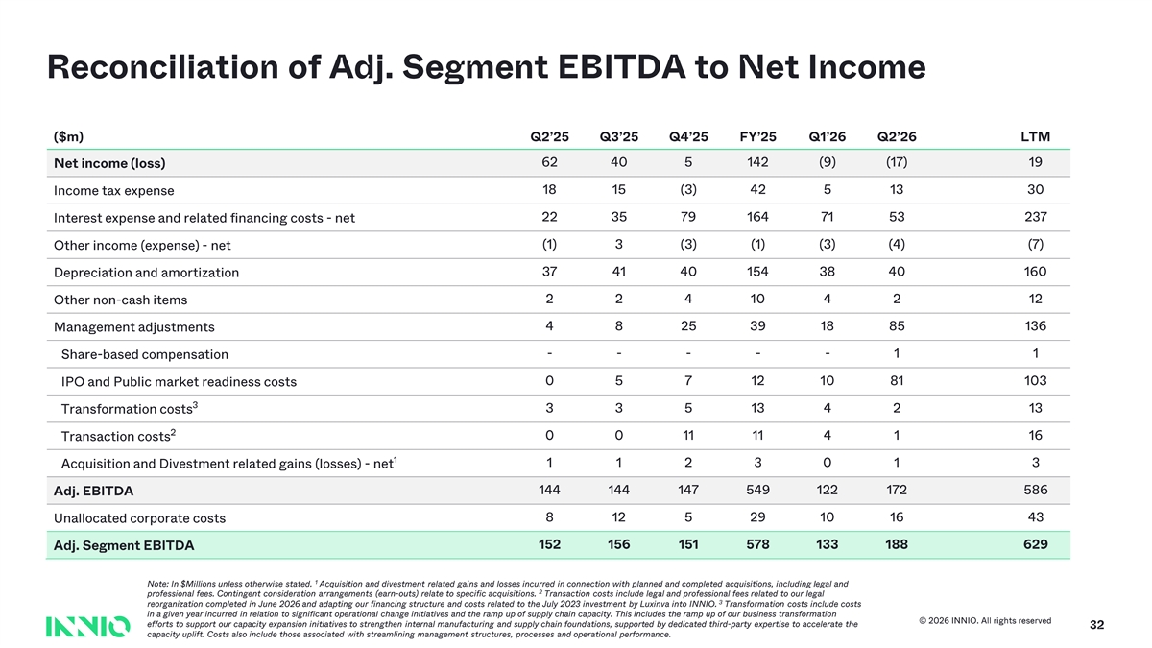
Reconciliation of Adj. Segment EBITDA to Net Income ($m) Q2’25 Q3’25 Q4’25 FY’25 Q1’26 Q2’26 LTM 62 40 5 142 (9) (17) 19 Net income (loss) 18 15 (3) 42 5 13 30 Income tax expense Interest expense and related financing costs - net 22 35 79 164 71 53 237 (1) 3 (3) (1) (3) (4) (7) Other income (expense) - net 37 41 40 154 38 40 160 Depreciation and amortization 2 2 4 10 4 2 12 Other non - cash items Management adjustments 4 8 25 39 18 85 136 - - - - - 1 1 Share - based compensation 0 5 7 12 10 81 103 IPO and Public market readiness costs 3 3 3 5 13 4 2 13 Transformation costs 2 Transaction costs 0 0 11 11 4 1 16 1 1 1 2 3 0 1 3 Acquisition and Divestment related gains (losses) - net 144 144 147 549 122 172 586 Adj. EBITDA 8 12 5 29 10 16 43 Unallocated corporate costs Adj. Segment EBITDA 152 156 151 578 133 188 629 1 Note: In $Millions unless otherwise stated. Acquisition and divestment related gains and losses incurred in connection with planned and completed acquisitions, including legal and 2 professional fees. Contingent consideration arrangements (earn - outs) relate to specific acquisitions. Transaction costs include legal and professional fees related to our legal 3 reorganization completed in June 2026 and adapting our financing structure and costs related to the July 2023 investment by Luxinva into INNIO. Transformation costs include costs in a given year incurred in relation to significant operational change initiatives and the ramp up of supply chain capacity. This includes th e ramp up of our business transformation © 2026 INNIO. All rights reserved efforts to support our capacity expansion initiatives to strengthen internal manufacturing and supply chain foundations, supp ort ed by dedicated third - party expertise to accelerate the 32 capacity uplift. Costs also include those associated with streamlining management structures, processes and operational perfo rma nce.

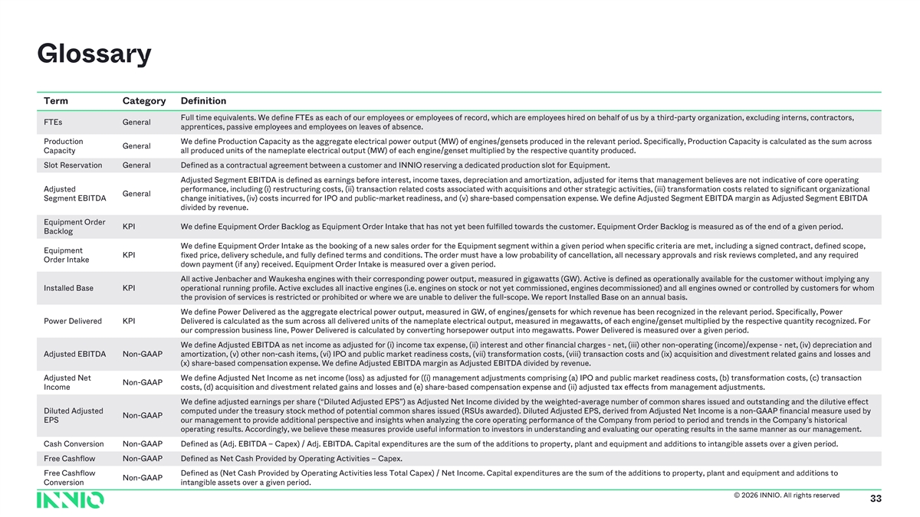
Glossary Term Category Definition Full time equivalents. We define FTEs as each of our employees or employees of record, which are employees hired on behalf of us by a third -party organization, excluding interns, contractors, FTEs General apprentices, passive employees and employees on leaves of absence. Production We define Production Capacity as the aggregate electrical power output (MW) of engines/gensets produced in the relevant perio d. Specifically, Production Capacity is calculated as the sum across General Capacity all produced units of the nameplate electrical output (MW) of each engine/genset multiplied by the respective quantity produc ed. Slot Reservation General Defined as a contractual agreement between a customer and INNIO reserving a dedicated production slot for Equipment. Adjusted Segment EBITDA is defined as earnings before interest, income taxes, depreciation and amortization, adjusted for ite ms that management believes are not indicative of core operating Adjusted performance, including ( i) restructuring costs, (ii) transaction related costs associated with acquisitions and other strategic activities, (iii) tran sfo rmation costs related to significant organizational General Segment EBITDA change initiatives, (iv) costs incurred for IPO and public - market readiness, and (v) s hare -based compensation expense . We define Adjusted Segment EBITDA margin as Adjusted Segment EBITDA divided by revenue. Equipment Order KPI We define Equipment Order Backlog as Equipment Order Intake that has not yet been fulfilled towards the customer. Equipment O rde r Backlog is measured as of the end of a given period. Backlog We define Equipment Order Intake as the booking of a new sales order for the Equipment segment within a given period when spe cif ic criteria are met, including a signed contract, defined scope, Equipment KPI fixed price, delivery schedule, and fully defined terms and conditions. The order must have a low probability of cancellation , all necessary approvals and risk reviews completed, and any required Order Intake down payment (if any) received. Equipment Order Intake is measured over a given period. All active Jenbacher and Waukesha engines with their corresponding power output, measured in gigawatts (GW). Active is define d as operationally available for the customer without implying any Installed Base KPI operational running profile. Active excludes all inactive engines ( i.e. engines on stock or not yet commissioned, engines decommissioned) and all engines owned or controlled by customers for whom the provision of services is restricted or prohibited or where we are unable to deliver the full -scope. We report Installed Base on an annual basis. We define Power Delivered as the aggregate electrical power output, measured in GW, of engines/gensets for which revenue has bee n recognized in the relevant period. Specifically, Power Power Delivered KPI Delivered is calculated as the sum across all delivered units of the nameplate electrical output, measured in megawatts, of e ach engine/genset multiplied by the respective quantity recognized. For our compression business line, Power Delivered is calculated by converting horsepower output into megawatts. Power Delivered is measured over a given period. We define Adjusted EBITDA as net income as adjusted for (i) income tax expense, (ii) interest and other financial charges - net, (iii) other non -operating (income)/expense - net, (iv) depreciation and Adjusted EBITDA Non -GAAP amortization, (v) other non -cash items, (vi) IPO and public market readiness costs, (vii) transformation costs, (viii) transacti on costs and (ix) acquisition and divestment related gains and losses and (x) share -based compensation expense . We define Adjusted EBITDA margin as Adjusted EBITDA divided by revenue. Adjusted Net We define Adjusted Net Income as net income (loss) as adjusted for (( i) management adjustments comprising (a) IPO and public market readiness costs, (b) transformation costs, (c) transaction Non -GAAP Income costs, (d) acquisition and divestment related gains and losses and (e) share -based compensation expense and (ii) adjusted tax ef fects from management adjustments. We define adjusted earnings per share (“Diluted Adjusted EPS”) as Adjusted Net Income divided by the weighted -average number of common shares issued and outstanding and the dilutive effect Diluted Adjusted computed under the treasury stock method of potential common shares issued (RSUs awarded). Diluted Adjusted EPS, derived from Ad justed Net Income is a non -GAAP financial measure used by Non -GAAP EPS our management to provide additional perspective and insights when analyzing the core operating performance of the Company fr om period to period and trends in the Company’s historical operating results. Accordingly, we believe these measures provide useful information to investors in understanding and evalua tin g our operating results in the same manner as our management. Cash Conversion Non -GAAP Defined as (Adj. EBITDA – Capex) / Adj. EBITDA. Capital expenditures are the sum of the additions to property, plant and equipment and additions to intangible assets over a giv en period. Free Cashflow Non -GAAP Defined as Net Cash Provided by Operating Activities – Capex. Free Cashflow Defined as ( Net Cash Provided by Operating Activities less Total Capex) / Net Income. Capital expenditures are the sum of the additions to property, plant and equipment and additi ons to Non -GAAP Conversion intangible assets over a given period. © 2026 INNIO. All rights reserved 33


31 Text 31 39 230 Background 231 234 36 Accents 1 219 130 0 2 49 166 77 3 130 255 110 4 38 154 201 5 153 230 132 6 132 158 140 Hyperlink 87 255 81 Followed 2 Hyperlink 255 27 INNIO Green 164 (Darker for text ) 98 211 INNIO Red 32 8 255 INNIO Yellow 241 92 0 34 INNIO Cyan 181 213

